Terms of Reference: Graphic Design Intern to collaborate with CUBIC

Background
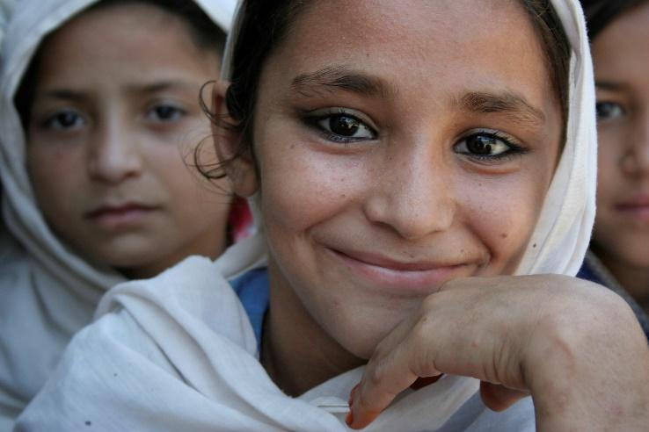
Save the Children is the world’s leading independent organization for children, working in 117 countries with more than 25,000 staff. In April 2020, Save the Children launched the Center for Utilizing Behavioral Insights for Children (CUBIC) in Asia. CUBIC is the first “nudge unit” in the world to focus specifically on the most marginalized children’s rights and welfare. We are a dynamic team, with ambitious goals to apply behavioral science in order to reach more children and have an even greater impact on their lives.

Projects
CUBIC is seeking an early career graphic design intern to support our Design Associate. High quality design is a central part of CUBIC’s offering to clients and partners, and we seek to maintain these standards across everything we produce – from behavioral protypes to presentations and reports.

Internship Objectives
The intern will be integrated into the 13-person CUBIC team and will have the opportunity to get involved in multiple projects – the expectation for the intern is that s/he would primarily contribute to:

- Project summary presentations
- Business development pitches/ proposals
- Communications product design
- Social media post design
- Proofreading final design output where required

Skills Required
- Enrolled in/or recent graduate of design qualification/ early career in design and communication
- Interest and experience in using design for charity communications or social enterprise
- Experience of developing communication products
- Experience with Adobe (Illustrator, InDesign, Photoshop) and Microsoft packages (specifically PowerPoint) content marketing strategies
- Excellent written communication skills (English language)
- Strong collaboration and teamwork skills
- Animation skills are desirable

Time Requirements
Part time internship – appropriate for students/recent graduates. Expectation is for 8-12 hours a week, for a minimum of 6 months.

Supervisor
CUBIC’s Design Associate as well as other team members

Conditions
The intern would be engaged on a voluntary basis (non-paid) and would sign a volunteer contract with Save the Children. The working schedule would be determined by the intern; however, attendance during regular team calls and calls with our country partner teams would be important.

Location
Remote/home-based, time zone up to GMT +/- 6hrs

