REQUEST for PROPOSAL

The Economic Consequences of Hazard Impacts on Education
Save the Children is the world’s leading independent organisation for children. We work in 120 countries. Our vision is a world in which every child attains the right to survival, protection, development and participation. Our mission is to inspire breakthroughs in the way the world treats children and to achieve immediate and lasting change in their lives. Our values are accountability, ambition, collaboration, creativity, and integrity. In 2015 we reached 62 million children directly through our programmes in health, nutrition, education, protection and child rights, and also in times of humanitarian crises. In 2015 our combined revenues were $2.1 billion.
Save the Children International Asia Regional Office is inviting submissions for proposals for conducting the following research:

- PURPOSE
The purpose of this research is to appraise the short- and long-term, tangible and intangible, direct and indirect economic consequences of intensive and extensive hazards impacts on the education sector, including and especially with reference to reducing educational inequities and disparities. Understanding the value that is exposed to risk will provide valuable information for policy-makers, advocates and donors regarding the need to assest cost benefits of variety of possible measures to reduce this exposure.

The project has two elements:
1) To Construct a framework to analyse the economic consequences of hazards on the education sector, and

2) To apply that framework to three case studies.

The framework should include the impact of hazards and associated policy responses on both
• education sector infrastructure (facilities, teaching and learning materials, etc.) as well as
• educational outcomes for students (achievement and attainment).
• The framework should be constructed so that it can be used for cost-effectiveness, cost benefit, and social return on investment analyses in the future.

The outcomes of this research will set the groundwork to inform integrated disaster risk management strategies for the education sector, by establishing the value exposed to damage. It will provide inputs to cost-effectiveness, cost-benefit, and social return on investment analyses in the future, allowing comparative assessment of investments in risk reduction, response and recovery. The research should contribute a useable model of disaster impacts on education, both by building on existing models for measuring education inequity and disruption impacts on individual income, and national economies, and disaster recovery cost information, as well as providing three applied case studies.

The purpose of the research is to build a broad economic hazard framework for the education sector that is capable of taking the targets and indicators established to support Comprehensive School Safety (CSS) and mapping them into a prioritisation of resources across activities to meet these goals. The activities cover: safer school facilities, school disaster management, and risk reduction and resilience education. They broadly include things that we do before a hazard occurs (assessment, mitigation, adaption) and things that happen following a hazard (response and recovery). To the extent possible, the research should report on options and priorities across these activities and their impact on infrastructure and outcomes in a way that reduces educational inequity and disparities

We need to understand the gross economic consequences of hazards on education, and design follow-on research to measure the cost-benefit impacts and the reductions in inequities and disparities that can be measured future with respect to specific policy and program interventions.

Research, supported by Save the Children, is currently being conducted in the Philippines in cooperation with the DepEd, to investigate hazard and disaster impacts (of all sizes) on the education sector between 2009 and 2016. That project is expected to provide sufficient data to produce a case study for this research. Two additional purposively selected case studies will be undertaken by the sucsesful consultant and should examine instances where intensive, recurrent, rapid onset natural hazard impacts have resulted in impacts to large numbers of children. The researcher will consider available data from authorities and researchers, and these may be selected from cyclones/floods in either Bangladesh, UK, or US, and earthquakes in either Nepal, Pakistan or Haiti. Selection of case studies will depend on researcher determination of quality of data readily available through partners. The objective is for the consultant to produce a standardised methodological framework to allow for direct comparison between the case studies.

The purpose of the detailed case study approach will be to shed light on the range of preemptive investments that may reduce underlying structural, non-structural, and social vulnerabilities. The analytical framework should be responsive to the targets and indicators, established to support Comprehensive School Safety, namely around: ensuring that every new school is a safe school, triaging and prioritizing unsafe structures for retrofit or replacement, implementing school-based risk reduction measures (including early warning), response-preparedness skills and provisions, educational continuity planning, and education in emergencies intervention.

- TITLE

The Economic Consequences of Hazard Impacts on Education: Analytical Framework and Case Studies

- PROJECT SUMMARY

The purpose of this research is to complete a study of the economic consequences of the impacts of intensive and extensive hazards on the education sector. This is to be completed through development and application of a framework to enable the quantification of short- and long-term, tangible and intangible, direct and indirect economic consequences of intensive and extensive hazards impacts on the education sector. Particular reference is to be made to reducing educational inequities and disparities. It is expected to address both the impacts on education sector assets (infrastructure as well as teaching and learning materials), as well as upon individual educational achievement and attainment and longer-term consequences for family socio-economic status.

- BACKGROUND

Education Safe from Disasters
Save the Children has launched an Education Safe from Disasters (ESD) strategy, which is a three-year Asia-Pacific regional strategy, aimed at strengthening Save the Children’s approach to Comprehensive School Safety, which aims to defend two fundamental child rights: the right to safety and survival, and the right to education. Governmental, inter-governmental, civil society, and private sector partners of the Global Alliance for Disaster Risk Reduction, the Worldwide Initiative for Safe Schools, and the Global Partnership for Education are all extremely interested to understand both disaster impacts on education, as well as cost-effective interventions to reduce these impacts.

The Asia region is the most disaster prone in the world, and children bear the brunt of the impact. Countries in the region experience infrequent high-impact hazards such as, earthquakes, tsunami, volcanoes; frequent lower-impact hazards such as cyclones and monsoons; slow-onset hazards such as drought, coastal erosion, and subsidence; and a range of social hazards including hazardous materials releases and conflict.

Children’s right to education, and policies and priorities for access to a free equitable quality basic education rest on assumptions about children’s ability to attend a target percentage of normative school days in order to make normative progress and benefit from their education. When schools are closed, used for other purposes or inaccessible, and when the school calendar or school attendance are significantly (and repeatedly) disrupted, when exam schedules are inflexible, children often fall behind, fail to achieve their goals, or drop out before finishing school. The consequences of educational inequities, disparities, and discontinuities are severe for individuals, families, and national welfare. Children who drop out of school face higher rates of poverty, exploitation, and violence. Whilst there is some evidence that coping with adversity is a learning and growth experience, there is also reasonable conjecture that equitable access to participation in a fairly high percentage of the normative annual school hours, is fundamental to the realizing right to education.

Comprehensive School Safety policy research, and communication from potential donors consistently indicates a great need to understand the cost of hazard impacts on education, as well as the cost of risk reduction options, and ultimately for cost-benefit studies. The pre-requisites for this are to be able to quantify the full range of damage to education sector and the children whose future depends on their access to education.

Natural Hazard Impacts in General
The study of economic and financial impacts of both natural and man-made hazards has demonstrated both short- and longer-term impacts on economic growth and development, with important policy implications when it comes to disaster risk reduction. For example, a recent World Bank report finds that, when accounting for impacts on well-being, natural disasters cost the global economy USD 520 bn (or 60 percent more than usually reported) and force some 26 million people into poverty every year (Hallegatte et. al. 2016). Poor and marginalized populations bear the brunt of disasters and climate shocks. Through their impact on human capital (in particular, nutrition, education, and health), disasters can severely affect household’s earning potential.

“There is substantial global knowledge and technology to support quantification of natural disaster risk across the full range of geographical and socio-economic settings. While specific risk models for education infrastructure and service interruption are rare, most developing world countries, including most of the 89 countries eligible for GPE financing under the financing and funding framework (FFF), are covered by some level of hazard and risk modeling. Through the use of proxies or collection of additional exposure information, detailed risk assessments for education systems are possible almost universally and covering most of the main natural hazard perils.” (GPE 2017. Task 2 Report Draft 2.0 p.iv)

In 2005, the Multihazard Mitigation Council of the National Institute of Building Sciences (NIBS, 2005) published the often quoted study that documented how every $1 spent on mitigation saves society an average of $4. The study (which did not look specifically at the education sector) found that FEMA mitigation expenditures resulted in reduced direct property damage, reduced direct and indirect business interruption loss, reduced non-market damage, human losses, and emergency response. The study is currently being updated, with more detailed and nuanced methods, and is expected to yield more accurate assessments of mitigation impacts. Of particular relevance to the education sector, the benefits of building safely, minimum retrofit, and facilities non-structural mitigation measures are expected to be quantified (Porter, 2017). In the meantime, some additional studies have found so-called “non-structural measures” to be more cost-efficient than structural counterparts, and prevention and preparedness strategies seem to be equally efficient (Hugenbusch & Neumann, 2016).

Cost-effectiveness analysis, cost-benefit analysis, and social return on investment play an important role in risk reduction planning. Such analysis begins with understanding the value being exposed to damage. While direct and tangible damage has been frequently and accurately assessed in engineering and education sector reconnaissance reports, indirect and intangibles associated with education sector disruption, and the incremental costs of delays in recovery, are much less well-articulated. And yet, these are thought to be considerably higher than damages which can be easily quantified in monetary terms (Dedeurwaerdere, 1998; UNISDR, 2011).

When it comes to identifying impact assessment of mitigation, three types of DRR strategies can be distinguished: Prevention/mitigation measures (i.e. physical risk reduction or mitigation, esp. structural, non-structural, infra-structural or environmental measures to reduce exposure) Preparedness (eg. early warning systems, response preparedness, contingency planning, response networks, awareness), and Risk Transfer (i.e. insurance and reserves). To the extent that risk reduction is not undertaken or is not fully effective, then the costs of Disaster Response and Recovery also come into play.

Educational Inequities in General

Equity in education (Field, 2007) is most frequently tackled in relation to educational achievement, attainment, and drop-out prevention. Many factors have been associated with drop-out, chief among these being poverty (OECD, 2007) Policies that promote fair and inclusive education are shown to make substantial difference (OECD, 2010).

However, in the existing literature on reducing educational inequities, the impact of educational disruption (and the length of that disruption) due to hazards and disasters has almost been entirely ignored in studies to date. The notion of ‘fairness’ has been widely used, but the normative number of days of annual and lifetime school attendance that hazards interrupt, have not. Prevention of school drop-out is often discussed, but not in relation to length of school disruption (due to either damage, use of schools as temporary shelters, inaccessibility of schools, major or repeated hazard impacts). “Second chances” and “accelerated learning” are discussed, but rarely in relation to post-disaster catch-up programs. Fair and inclusive resourcing is discussed, but not in relation to either pre-disaster mitigation investments, educational continuity planning, or post-disaster education.

Disasters Impacts on Education in General
Disaster impacts fall unequally on people of lower socio-economic status and further depress these conditions. Educational inequities are similarly associated with lower socio-economic status. Thus when it comes to disaster impacts on education, already deprived and marginalized children potential face a double jeopardy. Education impacts are complicated, including because beyond the more obvious infrastructure damage, and school disruption consequences for education, nutrition and health outcomes can also be dependent upon school participation (Baez et. al., 2010; GPE, 2017. Task 1 Annex 1).

Some of the limited data found is alarming. After Hurricane Mitch struck Nicaragua in 1998, child labor increased as much as 58% in affected areas, and the number of children who dropped out or working more than doubled (Baez & Santos, 2007). Recent reports from Pakistan, 11 years after the 2005 earthquake there, include calls to rebuild more than 200 schools destroyed – implying that the equivalent of an entire K-12 cohort of students of these schools have been entirely denied the educational rights that were being fulfilled before the earthquake (Dawn, 2016). The impact of short-term gains to families through children’s labor market participation remain to be compared to longer-term gains of staying in school.

Substantive and comparable quantitative data that demonstrates economic impact on the education sector, is needed to understand potential financial and economic returns to specific policy and program options when it comes to risk reduction, structural safety, preparedness, contingency planning, and response measures. Current evidence is simply insufficient as the basis for formulating these integrated risk management strategies. (Benson & Clay 2004, GPE 2017). There is substantial consensus that purposively selected, detailed, disaggregated case studies are needed to generate the information and understanding for governments to understand and justify the actions to be taken.

A recent study by the Global Partnership for Education provides the first analytical framework for understanding short-term and long-term costs associated with impacts on: students, delivery system, teachers, and physical infrastructure (GPE, 2016). The proposal for this research should consider how the results of the GPE study can be utilized as background for this study.

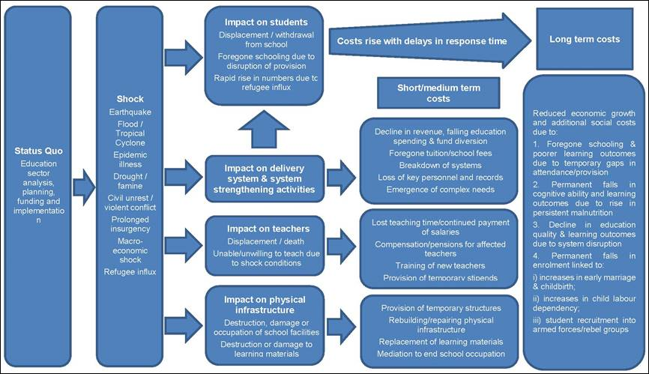
Analytical Framework for shock impacts on education. (GPE 2017. Task 1 Report Draft 3 p. 14

The clearest direct impacts on education sector investments are the damage and destruction of:

• school classrooms

• teaching and learning equipment and materials

• water and sanitation facilities.

Some of the significant impacts results from the use of schools as temporary shelters. These impacts have been noted in terms of physical damage to buildings, furnishings, equipment, teaching and learning supplies and water and sanitation facilities by displaced occupants – which are often not compensated or result in very delayed recovery. In addition, a the disruption to education by prolonged use of classrooms, which may force either cancellation or shortened class hours, or sub-optimal conditions such as over-crowding, noise, interruptions and distractions (Cadag et. al. 2017)

When it comes to assessing the indirect impacts on educational access, our starting point is the normative number of school days set by each country for primary and secondary education (eg. 180 days, though many are longer). The number of hours in the school day can vary considerably (eg. 5.5 hours per day is common, however in many places, and for each instruction levels – early childhood programs and kindergarten, early primary, late primary, middle and upper schools – the day may be shorter or longer). Whilst the literature contains many measures and factors in educational equity, the underlying metrics are student-teacher contact hours, assuming generally stable teacher attendance, and classroom size (number of students per teacher). In places with recurring school disruption due to flooding, the cumulative impact on these two measures of educational equity across a child’s school ‘career’ have neither been measured nor estimated

Some of the important metrics in understanding the indirect impacts of hazards on education involve assessing impacts such as:
• school closure due to inundation and/or damage, or use of schools as temporary shelters.
• school days or hours shortened due to damage or use of schools as temporary shelters.
• children or teachers not attending due to physical inaccessibility, lack of or cost of transportation, or displacement.
• made up time and accelerated learning may not be as conducive to learning (perhaps especially for slower learners).
• displaced children’s access and adjustment to school in a new location.
• psychosocial impacts especially on attention and concentration, for both students and teachers.
• damage to water and sanitation facilities may also have depressive effect on attendance and enrolment.

These impacts and the mitigation measures being taken to address them may be measured in a variety of ways by looking at comparisons between impacted and non-impacted populations, and populations with and without mitigation and preparedness programming in terms of: overall reduced student-teacher contact hours, enrolment, attendance, advancement, continuation between primary and secondary school, drop-out, national test performance etc. Though as yet unmeasured, individual impacts can be expected to include short- and long-term consequences for educational achievement and attainment. Outcomes may be impacted by rapid resumption of schooling, by community and student engagement in educational continuity planning.

There may be complicating factors when it comes to measuring hazard-induced inequities in educational access. For example:
• enrolment rates are notoriously easy to inflate and are very poorly correlated with actual daily attendance and regular participation in school.
• a variety of factors may inhibit children’s consistent attendance (and therefore lead to lack of success, repetition and drop-out). For example, pressure for children to participate in livelihood or child care activities, distance and safety of the route to school, availability of clothing and footwear in relation to weather.
• lack of appropriate water and sanitation facilities at school is a deterrent especially to girls’ participation.

Other important indirect impacts mentioned in the literature are related to the interruption of school health and nutrition programs.

Educational continuity planning and rapid resumption of education
Knowing that school days lost has multiple consequences, many jurisdictions faced with hazard impacts, the general policy is to minimize school days and hours lost. However, in many cases of large-scale emergencies, schools are officially closed for a very limited number of days for safety, to conduct damage assessment and clean-up, and where equity considerations make this practical. Strategies for rapid resumption of schooling, minimizing school days lost, making up hours. School disruption also has impacts on community, family and individual recovery. The success of rapid school resumption seems to also have a ripple effect, making it possible for adults being able to focus on clean-up and recovery and resumption of livelihood activities, including occupational and family-based routines (known as predictors of recovery). There are a variety of methods addressing rapid resumption of education, the logic of which is that rapid resumption is important. The economic consequences of every additional school day lost, may help inform cost-benefit calculations associated with rapid resumption of schooling.

- POTENTIAL CASE STUDY DATA

Report should include 3 case studies. Save the Children has made initial efforts to identify potential case studies.

Data from the Philippines (longitudinal 2009-2016)
Dep Ed in the Philippines has been collecting data systematically on hazard impacts on schools since 2009 hazards, as well as from use of schools as evacuation centers. Over these 5 school years, there were reports of impact from 10 different types of natural and man-made hazards

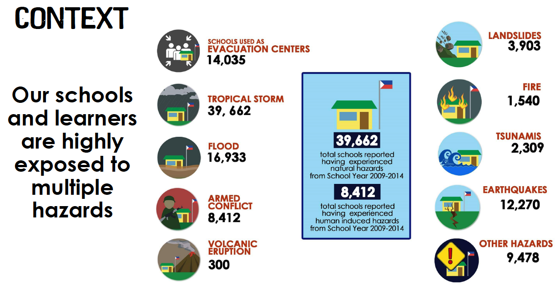
Figure: Disaster Impacts on Education in the Philippines. Source: Dep Ed DRRMS Presentation, 2017.

Data currently being gathered from the Philippines will answer the following questions:
• What are the range of hazards to impact the education sector in the Philippines over the 7 school years between 2009 and 2016?
• What have the educational impacts been of hazards of all sizes, in the Philippines between 2009 and 2016?
• What have the economic impacts been of hazards of all sizes, on education sector infrastructure investments in the Philippines between 2009 and 2016?
• What kinds of inequities are caused by hazard impacts in the Philippines?
• Are there a critical number of school days disrupted either at one time, or cumulatively over a student’s school years beyond which negative impacts are seen on educational achievement and attainment?
• Are there any adaptive interventions that have positive impact on these outcomes (eg. availability of temporary learning spaces, rolling resumption of school, adjusted calendar, accelerated learning, actively involving children in recovery activities, how use of school as temporary shelter is managed, percentage of children reached with adaptive interventions)
• What recommendations can be made regarding data collection and analysis in relation to DepEd DRRM’s strategic plan (Dep Ed Order No 37, S.2015), Student-led School Watching and Hazard Mapping (Dep Ed Order No 23, S. 2015)
Researchers undertaking that project will be sharing data as soon as available, for use in a case study.
Potential Case Study Data from Nepal (2015 earthquakes):
The impact of the Nepal earthquake (measuring 7.8 on the Richter scale) on 25 April 2015 was profound. Over 36,000 classrooms were destroyed and an additional 17,000 classrooms damaged in the earthquake and the subsequent aftershocks, disrupting education of more than 1 million children (UNICEF, 2015) through loss of learning spaces, teaching and learning materials and the psychological impacts. The Nepal Education Cluster estimated the total costs needed to support the Education response were $24.1 million ($24.1 per child) and by June 2015 only 47% ($11.3 million) had been received, and by that point in time 1007 temporary learning centres had been established, supporting school access for 100,700 children. Longitudinal data has not been reported. Save the Children has strong partnerships with Nepal’s National Society for Earthquake Technology, and Ministry of Education. Key contacts believe that there is considerable data available that can be mined with respect to the physical damage to the education sector, caused by the Nepal Earthquake, as well as data regarding longer term educational disruption.

Other Potential Case Studies:

Other potential case study data might be obtainable from researchers and government authorities with respect to the following disaster impacts.
• Hurricane Katrina – U.S
• York floods – U.K.
• Cyclones – Bangladesh (Ministry of Health data)
• Earthquake – Pakistan
• Earthquake – Haiti

2. RATIONALE

This study aims to complement other recent studies on the barriers to achieving children’s right to a free basic quality education, and to identify significant sources of inequities in educational participation, as the result of hazards, disasters, and climate-change impacts.

The study will generate the foundational evidence on economic consequences of disaster impacts on the education sector in order to recommend and point the way forward to both risk reduction investment options, as well as to long-term data collection, and future research. An understanding of the financial and economic consequences of a variety of hazard impacts on the education sector is needed to support recommendations for policy implementation, as well as to propose a way forward for ongoing research and analysis in this field

The case studies will begin to document and provide constructive examples for many hazard prone countries in their efforts to understand the impacts of hazards on education, and to address educational inequities with thoughtful, evidence-based planning and decision-making. The results are expected to guide education sector partners, development partners, donors, and other stakeholders in reducing hazard and disaster impacts on the education sector.

3. AIM, OBJECTIVES & RESEARCH QUESTIONS
This section can be revised with selected researcher(s), and upon consultation with key stakeholders, especially with education authority partners, and country office TA.

Aim:
To understand the economic consequences of hazards impacts on both educational outcomes for children, and on education sector investments from a theoretical perspective as well as from case study examples.

Objectives:
• To understand the differential and longitudinal economic consequences of hazards impacts on children’s education outcomes (including larger intensive disaster impacts and extensive and recurrent impacts of hazards);
• To understand the economic impacts of hazards on education sector investments;
• To utilize quantitative data for analysis of economic consequences of hazard impacts in three case studies.

Proposed Research Questions:

Researchers are invited to formulate the proposed research questions in their proposal and in their inception report.

7. SCOPE of WORK and DELIVERABLES

Note that any results that are to be published in a peer-reviewed academic journal will require approval by academic institutional human subjects or ethics board.
- Inception Report
This report will refine the research questions, outline the work plan for conducting the study, a time frame for completion of each step, agreements from major stakeholders on the scope, and detail the methodologies and resources to be used.

- Research-into-Practice Brief
This 2,000-word brief will provide a concise academic literature review of how the economic consequences of educational inequities and disparities can be measured and understood, as a primer geared towards practitioners. The review template will be provided, and covers:
Abstract (100 words)
Short Glossary of important terms
Introduction (100 words)
Literature Review (approx 850 words)
Case Study (approx 250 words)
Practical applications (approx 250 words)
Conclusions (approx 250 words)
Important Lessons (approx 250 words)
Follow-up Questions (5)
References (<10)
Bibliographic References (as many as needed – submitted into Mendeley shared bibliography)

- Final Report
The final report will concisely (20 pages or less plus appendices) present the main findings and recommendations with regards to the overall objective and research questions outlined in this terms of reference, incorporating feedback from Save the Children and other relevant stakeholders.
Acknowledgements
Table of Contents
Executive Summary
Introduction and Background
Purpose and Research Questions
Research Design and Methodology (sample, data collection, data analysis, limitations)

Research Findings
Discussion (including link to other research, the guiding research narrative and translation/utilization goals).
Recommendations (must include: research dissemination and utilization goals and actionable utilization plans)

References
Appendices:

4. PowerPoint presentation of findings for general practitioner and stakeholder workshop
5. Full data set (where applicable)

8. QUALIFICATIONS

Applicants may be an individual or a team.

Applicants should demonstrate that the team has:
• A qualified economist
• Subject-matter expertise in education sector research
• Subject-matter expertise in disaster impacts research
• Subject-matter expertise in educational inequities research

• Strong research design and quantitative data analysis skills
• Excellent writing, conceptual and analytic skills, including being able to write for practitioners and policy-makers
• Proven track record in designing and implementing social science research
• Commitment to research dissemination and interest in implementation science highly desirable
• Appropriate cultural and language skills to carry out research in this particular context

In accordance with Save the Children's child safeguarding policies, all team members selected will be requested to sign SC's Child Safeguarding Policies.

9. RESPONSIBILITIES
The Save the Children and DepEd Research Project Support Team will guide and review the research methodology and outputs:
• Karimi Gitonga, the Children ESD Knowledge Management Advisor
• Dr. Marla Petal, Save the Children Senior Advisor for Education and Disaster Risk Reduction
• Dr. Kat Haynes – Education Safe from Disasters Academic Advisory Group
• Marit Aakvaag – DRR Advisor, Save the Children Norway

10.APPLICATIONS

Application should include:
• Cover letter stating interest and qualifications
• CV(s) and/or introduction of institute, company and primary investigators (please ensure to include contact information including phone number and email address)
• Links to 1 or 2 sample research work products
• Full proposal based on the above description of this research

Full Proposal should include:
1. Brief review of relevant literature (This is not meant to be extensive or definitive. However, it should indicate awareness of significant contributions in the field from both relevant scientific and academic texts as well as grey literature. It should indicate careful consideration of critical inquiry into carefully selected issues, clarify the 'gap' that the research should focus on, and create a space for the theoretical orientation and guiding model for the research. It can also indicate further areas of review that will be included in the course of the project).
2. Discussion of objectives and research questions
3. Research design insights (Include and justify proposed methods to ensure rigorous, generalizable results. Describe wherever possible: rationale, sampling approach, data collection process, assumptions, limitations, analysis, and models. Where applicable, include procedures to ensure ethical research practice, such as gaining Informed Consent, and protecting participant confidentiality, and protecting children. Where applicable indicate to which organization ethical review will be submitted.
3. Research Team Roles and CVs
4. Budget

Review, Interviews, Notification:
If you are interested in this tender, please follow the below link to our Save the Children website to review the full request of proposal documents, how the express of interest needs to be received and whom to contact for any further information requirement. https://www.savethechildren.net/tenders

Application deadline to return your application submission must be received at the email address below not later than October 22nd 2017 ("the Closing Date"). Failure to meet the Closing Date may result in the tender being void. Returned proposals must remain open for consideration for a period of not less than 60 days from the Closing Date. Save the Children is under no obligation to award the contract or to award it to the lowest bidder. [esdresearch@savethechildren.org]

11. TIMELINES & MILESTONES

Research Duration: Nov 1st, 2017 – February 1st 2018 (end date may be subject to change based on submitted proposals)

DELIVERABLES:

- Inception Report – by November 15th, 2017
- Draft Research-Into-Practice Brief – by December 8th, 2017 (revisions within 7 days of feedback)
2,000 word concise review of literature summarizing findings with respect to economic impacts of educational disruption and inequities. (format to be provided).
- Draft Final Report – by January 22nd, 2018 (revisions within 7 days of feedback)
• Full Research Report (20 pages + appendices) (for technical practitioner audience).
• Research Summary Report (4-6 pages) (for public stakeholder audience)
- Powerpoint presentation of findings for stakeholder workshop – by January 22nd, 2018
- Presentation of findings and recommendations (may be via remote webinar) – by January 31st, 2018 (by arrangement)

12. BUDGET
Budget range: Max EUR 45,000

• Payment will be made in 2 tranches: 40% upon receipt of approved inception report and 60% upon receipt of approved final deliverables.
• The researcher/research team is responsible for all travel, telecommunications and other costs as may be required.
• Research proposal should include all anticipated costs.

13. OVERSIGHT & ACCOUNTABILITY
Contractor will report to the Research and Learning Program Manager, and will be guided by a Research Project Guidance Team, represented by an assigned Save the Children TA Lead, as well as an independent Academic Research Advisor (assigned by Save the Children). The team will function as resource persons, to support the primary researcher (and team, where applicable), to produce quality outputs and guide effective research dissemination and next steps in implementation.

Save the Children will provide templates for layouts of final Research-into-Practice Brief, Final Report, and Powerpoint presentations. Researchers will also be provided with a Quality Review Checklist for the R2P Brief and the final reports. Peer review, final edit and 1-page summary of Research-into-Practice Brief will be completed by Risk Frontiers. Researchers are expected to arrange for professional copy-edit, info-graphics, and layout of Research Summary Report, as appropriate.

14. PUBLICATION & DISSEMINATION OF RESULTS:
This research is a 'work for hire', and as such, Save the Children reserves the right to retain the data collected and to publish research report. Primary Investigator and Research Project Team are encouraged to consider submission of appropriate publications to both peer-reviewed journals, and relevant and national regional publications. Any such submission requires prior approval from Save the Children.

REFERENCES / SOURCES

_________ A World at School (Feb. 11, 2015). Efforts to get 350,000 children back in school after Malawi floods chaos http://www.aworldatschool.org/news/entry/malawi-floods-put-350000-children-out-of-school-1579

Alderman, H.; Hoddinott, J.; & Kinsey, B. (2006). Long term consequences of early childhood malnutrition, Oxford Economic Papers, 2006, vol. 58, issue 3, 450-474 (h.alderman@cgiar.org) (jfh246@cornell.edu)

Baez, J., de La Fuente, A., Santos, I.V. (2010). Do natural disasters affect human capital? An assessment based on existing empirical evidence (IZA Discussion Paper No. 5164). Retrieved from http://ftp.iza.org/dp5164.pdf

Baez, J., Santos, I.V. (2007). Children's Vulnerability to Weather Shocks: A Natural Disaster as a Natural Experiment. Mimeo, Syracuse University.

Barro, R.J., Lee J.W. (2013). A new data set of educational attainment in the world. Journal of Development Economics, 104(C), 184-198.

Beegle, K., Dehejia, R. & Gatti, R. (2009). Why should we care about child labor? The Education, Labor Market, and Health Consequences of Child Labor, The Journal of Human Resources, V.44 No. 4 p.871-889. http://jhr.uwpress.org/content/44/4/871.short

Beegle, K., Dehejia, R., Gatti, R. & Krutikova, S. (2008). The Consequences of Child Labor: Evidence from Longitudinal Data in Rural Tanzania. The World Bank. https://elibrary.worldbank.org/doi/abs/10.1596/1813-9450-4677

Benson, C. & Clay, E. J. (2004). Understanding the Economic and Financial Impacts of Natural Disasters, Disaster Risk Management Series No. 4. The World Bank.

Benson, C. & Twigg, J. (2004). Measuring Mitigation. Methodologies for Assessing Natural Hazard Risks and the Net Benefits of Mitigation. A Scoping Study. Geneva.

Boyden, Jo & Stefan Dercon (2012). Child Development and Economic Development: Lessons & Future Challenges, Young Lives. https://www.researchgate.net/profile/Jo_Boyden/publication/268291563_Child_Development_and_Economic_Development_Lessons_and_Future_Challenges/links/551ac4060cf2fdce8437622b.pdf

Cabot Venton, C. (2014). Making the Economic Case for Safe Schools. Plan International. Woking.

Cadag, Jake, R., Petal, Marla; Luna, Emmanuel; Gaillard, J.C.; Pambid, Lourdes; Santos, Genia (2017) Hidden disasters: Recurrent flooding impacts on educational continuity in the Philippines (under submission, available from authors)

Castelló-Climent, A., Doménech, R. (2012). Human capital and income inequality: Some facts and some puzzles (BBVA research working papers 12/28).

Clarke, D.J., Dercon, S. (2016). Dull Disasters? How Planning Ahead will Make a Difference. DOI:10.1093/acprof:oso/9780198785576.001.0001

Coburn, A.W., Bowman, G., Ruffle, S.J., Ralph, D., Tuveson, M. (2013). A taxonomy of threats for macro-catastrophe risk management, Cambridge risk framework series. Cambridge, UK: Centre for Risk Studies, University of Cambridge.

Convery, I., Carroll, B., & Balogh, R. (2015). Flooding and schools: experiences in Hull in 2007. Disasters, 39(1), 146-165.

Cook, Glenn (2006). Schooling the Forgotten Kids of Hurricane Katrina, Education Digest V71 N9 p.7-13

Cook, Glenn (2006). Schooling Katrina’s Kids, American School Board Journal, 195 (4) p.18-26

Dawn (Nov. 25, 2016). Call to rebuild schools destroyed in 2005 quake. https://www.dawn.com/news/1298543/call-to-rebuild-schools-destroyed-in-2005-quake

De Janvry, A., Finan, F., Sadoulet, E., & Vakis, R. (2006). Can conditional cash transfer programs serve as safety nets in keeping children at school and from working when exposed to shocks? Journal of Development Economics, V.79 N.2, P 349-373. http://www.sciencedirect.com/science/article/pii/S0304387806000095

Dedeurwaerdere, A. (1988). Cost-Benefit Analysis for Natural Disaster Management. A Case Study in the Philippines. Louvain-la-Neuve (CRED Working Paper Nr. 143).

Dercon, S., Porter, C. (2014). The long run impact of severe shocks in childhood: Evidence from the Ethiopian famine of 1984. Journal of the European Economic Association 12(4), 927–948. DOI: 10.1111/jeea.12088

Felix, E., You, S., & Canino, G. (2013). School and Community Influences on the Long Term Post-Disaster Recovery of Children and Youth Following Hurricane Georges. Journal of community psychology, 41(8), 1021.

Field, S., Kuczera, M. & Pont, B. (2007). No More Failures: Ten Steps to Equity in Education, OECD Education and Training Policy. Paris.

Fothergill, A. & Peak, L. (2015). Children of Katrina. Austin. University of Texas.

Gitter, S. & Barham, B. (2007). Credit, natural disasters, coffee, and educational attainment in rural Honduras, World Development V.35 N.3 p.498-511

Gitter, S. & Barham, B. (2008). Conditional cash transfers, shocks, and school enrolment in Nicaragua, Journal of Development Studies, V.45 N.10 http://www.tandfonline.com/doi/abs/10.1080/00220380902935857

Global Alliance for Disaster Risk Reduction and Resilience in the Education Sector (2016). Comprehensive School Safety Framework, endorsed by, inter alia: UNESCO, UNICEF, UNISDR, IFRC, INEE, Save the Children, Plan International and World Vision http://www.gadrrres.net

Global Alliance for Disaster Risk Reduction and Resilience in the Education Sector (GADRRR-ES)(2017). Comprehensive School Safety. April 2015. CSS Targets and Indicators and Concept Note for Phase Two

Global Partnership for Education (2017). Sustaining the Gains: Feasibility of Risk Financing for Education.
• Task 1 Report Annexes. Overseas Development Institute in conjunction with Start Network and Save the Children with inputs from Willis Towers Watson.
• Task 2 Report: Applicability of Existing Catastrophic Risk Models and Risk Transfer Programs to Education. Willis Towers Watson, Start Network, Overseas Development Institute (2017).

Global Partnership for Education (2015g). Guidelines for education sector plan preparation. Paris: International Institute for Educational Planning; Washington DC: the Global Partnership for Education.

Global Partnership for Education (2016b). Guidelines for transitional education plan preparation (Country guidelines). Retrieved from http://www.globalpartnership.org/library

Government of the Philippines (2013). Reconstruction assistance on Yolanda. Retreived from http://www.gov.ph/downloads/2013/12dec/20131216-RAY.pdf

Guha-Sapir, D., Below, R., Hoyois, Ph. (2017). EM-DAT: The CRED/OFDA International Disaster Database, www.emdat.be. Brussels: Université Catholique de Louvain.

Hallegatte, S., Vogt-Schilb, A., Bangalore, M., Rozenberg, J. (2016). Unbreakable: Building the Resilience of the Poor in the Face of Natural Disasters. World Bank Publications.

Hugenbusch, D., & Neumann, T. (2016). Cost-benefit analysis of disaster risk reduction: a synthesis for informed decision-making. Aktion Deutschland Hilft.

International Commission on Financing Global Education Opportunity (2016). The Learning Generation: investing in education for a changing world. http://report.educationcommission.org/wp-content/uploads/2016/09/Learning_Generation_Full_Report.pdf

Jakubowski Maciej (2010) ―Institutional Tracking and Achievement Growth: Exploring Differences; published in: Jaap Dronkers (ed.) Quality and Inequality of Education. Cross-National Perspectives‖, 2010, Springer

Jones, A., Naylor, R. (2014). The quantitative impact of armed conflict on education: Counting the human and financial cost. CfBT Education Trust.

Justino, P. (2010). How does violent conflict impact on individual educational outcomes? The evidence so far (Background paper prepared for the Education for All Global Monitoring Report 2011). Brighton, UK: University of Sussex.

Kahn, Amir Nawaz & Ali Amjad (2013). Chapter 7 Implication of Floods – 2010 on Education Sector in Pakistan in Shaw, Rajib ed. Disaster Recovery. http://link.springer.com/chapter/10.1007/978-4-431-54255-1_7.

Lassa, Jonathan (2013). A Post-Disaster Monitoring Study of DKI Jakarta Flood 2013. Save the Children.

Levin, H. (2005). The Social Costs of Inadequate Education, Chair summary of the Teachers‖ College Symposium on Educational Equity, Columbia University, Oct. 2005

Mudavanhu, Chipo (2014). The impact of flood disasters on child education in Mazarbani District, Zimbabwe Jamba, Journal of Disaster Risk Studies V6 N1 http://www.jamba.org.za/index.php/jamba/article/view/138.

National Institute of Building Sciences, Multihazard Mitigation Council (2005). Natural Hazard Mitigation Saves: An Independent Study to Assess the Future Savings from Mitigation Activities. Vol. 1 – Findings, Conclusions, and Recommendations. http://www.preventionweb.net/files/1087_Part1final.pdf Vol. 2 – Study Documentation http://www.preventionweb.net/files/1087_vol2.pdf

National Institute of Building Sciences, Multihazard Mitigation Council (2017). Natural Hazard Mitigation Saves 2.0, Forthcoming

Nhan-O’Reilly, J., Mason, C. (2015). More and better: Global action to improve funding, support and collaboration for education in emergencies. London: Save the Children.

Nicolai, S., Hine, S. (2015). Investment for education in emergencies: A review of evidence (Report). London: Overseas Development Institute.

Nicolai, S., Hine, S., Wales, J. (2015). Education in emergencies and protracted crises: Toward a strengthened response. London: Overseas Development Institute.

National Clearinghouse for Educational Facilities (2011). Flooding and Schools. http://www.ncef.org/pubs/flooding.pdf

Overseas Development Institute (2016). A common platform for education in emergencies and protracted crises: Evidence paper. London: Overseas Development Institute.

OECD (2007). No More Failures: Ten Steps to Equity in Education.

OECD (2010). Overcoming School Failure: Policies that Work.

OECD (2010). Equity and Quality in Education: Supporting Disadvantaged Students and Schools
http://www.oecd.org/edu/school/equityandqualityineducation-supportingdisadvantagedstudentsandschools.htm

OECD (2010). The High Cost of Low Educational Performance: The Long-run Economic Impact of Improving PISA Outcomes; Program for International Student Assessment https://www.oecd.org/pisa/44417824.pdf

Porter, Keith (2017). Personal communication.

Save the Children (2017). Education Against the Odds: Impact of Hazards and Disasters on Access to Education in Lao PDR. Vientiane, Lao.

Save the Children (forthcoming). Post-Disaster Education Continuity in Fiji, and the Impact of Disaster Risk Reduction and Education in Emergencies Programming. Suva, Fiji.

Save the Children (2015). Education Disrupted: disaster impacts on education in the Asia Pacific region in 2015.

Save the Children (2014). Impact of 2012/2013 floods on education sector in Metro Manila and impact of education in emergencies policies, practices and capacity on response to Manila floods.

Shreve, C.M. & I. Kelman (2014). Does Mitigation Save? Reviewing Cost-Benefit Analyses of Disaster Risk Reduction, International Journal of Disaster Risk Reduction 10, S. 313-235. http://www.sciencedirect.com/science/article/pii/S2212420914000661 (See also https://view.officeapps.live.com/op/view.aspx?src=http://www.ilankelman.org/miscellany/MitigationSaves.doc )

Schäferhoff, M., Jamison, D., Pradhan, E., Suzuki, E.M., Martínez, S. (2016). Estimating the economic returns of education from a health perspective Background Paper - The Learning Generation. The International Commission on Financing Global Education Opportunity.

Stuart, K.L., Patterson, L.G., Johnston, D.M., and Peace, R. (2013). Managing temporary school closure due to environmental hazard: Lessons from New Zealand. Management in Education, Vol. 27 No. 1, pp. 25-31. doi: 10.1177/0892020612468928.

Syed Gulzar, Ali Shah Bukhari (2___). Flood Disasters and its Impacts on Child Education in Sindh https://www.academia.edu/5526296/FLOOD_DISASTERS_AND_ITS_IMPACTS_ON_CHILD_EDUCATION_IN_SINDH

Tallo, George (2014). Factors influencing implementation of flood disaster safety standards in public primary Schools in Uranga Division, Siaya County, Kenya. University of Nairobi. http://erepository.uonbi.ac.ke/handle/11295/74047

UNESCO (2015). Education for all, 2000-2015: Achievements and challenges —EFA global monitoring report 2015. Paris: UNESCO.

Walker M, Whittle R, Medd W, Burningham K, Moran-Ellis J & Tapsell S. (2010) Hull Children’s Flood Project Final Report, Lancaster, UK: Lancaster University

Wisner et al (2004). School Seismic Safety: Falling between the Cracks? http://www.ilankelman.org/articles1/wisneretal.2004.pdf

Witten, K., McCreanor, T., Kearns, R., & Ramasubramanian, L. (2001). The impacts of a school closure on neighbourhood social cohesion: narratives from Invercargill, New Zealand. Health & Place, 7(4), 307-317.

ANNEX to Request for Proposal

The Economic Consequences of Hazard Impacts on Education

Notes from recent GPE Reports:

Global Partnership for Education (2017). Sustaining the Gains: Feasibility of Risk Financing for Education. Task 1 Report: Applicability of Existing Catastrophic Risk Models and Risk Transfer Programs to Education. Draft 2. Overseas Development Institute in conjunction with Start Network and Save the Children, with inputs from Willis Towers Watson.

Executive Summary
With global exposure to disasters increasing (United Nations, 2015), investments in education are at risk from both natural disaster and political shocks. Natural disasters are currently estimated to affect 175 million children per year (UNICEF 2014), and half of out-of-school children of primary school age live in countries affected by conflict (UNESCO 2013).

The GPE portfolio has significant exposure to natural disaster and political risk. Almost all GPE countries are exposed to one or more natural catastrophe types, and a significant portion are fragile states and / or at risk of politically-driven crises and macro-economic shocks. This report finds that from 2000 to 2016, 79 out of 89 GPE countries reported a flood event, 53 reported drought, 44 reported storms, and 20 reported at least one earthquake event. In addition, political risk exposure in the GPE portfolio is substantial, with 42% of GPE partner countries classified as Fragile and Conflict-Affected Countries (FCAC).

Impacts to the education sector are complex and cascading, and shocks and disruption to education have costs which reverberate beyond initial disaster recovery. Losses to education in GPE partner countries from 2000 to 2016 are estimated to total a minimum of USD 11.6 billion from natural disaster events alone. Direct and indirect impacts of shocks create substantial long-term economic and health costs, which substantially outweigh the immediate costs of rebuilding education systems.

Funding to respond to shocks in education systems is not prioritized and is poorly coordinated, which results in significant economic and social costs. Very little structured risk management is currently in place in the education sector, and the traditional response to shocks is reactive rather than pre-planned and coordinated. Humanitarian funding allocations to education have averaged 2.1% over 10 years, and financial preparedness for shocks is low. The most significant cost of this system is the long-term socioeconomic cost of foregone schooling. Estimates from recent crises suggest that lower education levels due to foregone schooling have resulted in losses varying from 1.3%-3.1% of GDP, with substantial additional costs arising from permanent increases in the number of out-of-school-children. depending on the context.

A comprehensive and structured disaster risk management approach can build resilience for the education sector to external shocks. This approach is based on understanding and reducing of hazard, exposure and vulnerability, but also on coordinated and pre-agreed post-disaster plans, backed by effective financial protection measures. The resilience dividend for the education sector could be substantial. Running a series of scenarios on recent examples of crises demonstrates that these vary from a 5% reduction in the delivery gap (i.e. the number of lost teaching days) resulting in savings equivalent to 15.7% of the direct costs of the crisis in Syria, to a 50% reduction in the delivery gap resulting in savings equivalent to 7,789% of the direct cost of the crisis in Pakistan.

Overall, risk financing mechanisms appear to be a promising avenue for development for GPE but require piloting and further analysis. There are a number of outstanding questions regarding the scale of the potential benefits of risk financing, the use of parallel approaches or careful selection of contexts to avoid capacity traps, and optimum design of the risk financing mechanism to balance the needs and interests of the different actors involved. Piloting and further analysis will therefore be key to establishing how viable and useful these approaches will be for GPE and will be addressed in Task 2 and 3 of this project.

p.9.
Emergency Events Database (EM-DAT), which is compiled by the Centre for Research on the Epidemiology of Disasters (CRED), based at the Université catholique de Louvain in Belgium, and focuses on natural catastrophe events compiled from various sources, including UN agencies, non-governmental organisations, insurance companies, research institutes and press agencies. EM-DAT data for all 89 GPE countries was analysed by hazard type for the period 2000 to 2016. Figure 2.1 shows that over the past 17 years, by hazard, floods affect the largest number of GPE countries, with earthquakes affecting the fewest countries. Further modelling and risk exposure data is presented in the Task 2 report.

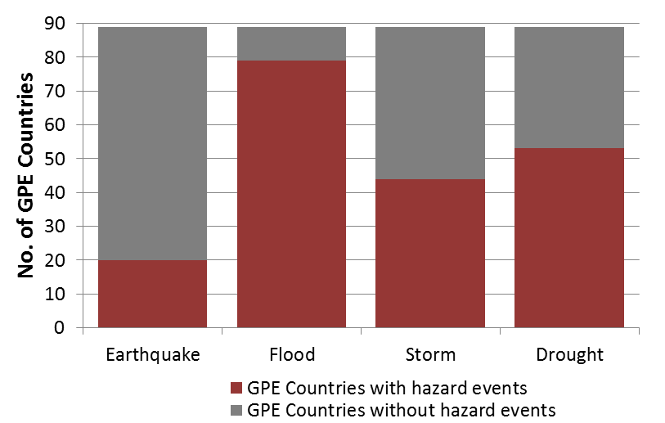
Figure 2.1 GPE countries and disaster event experience, 2000 – 2016.

GPE (2017). Sustaining the Gains: Feasibility of Risk Financing for Education. Task 2 Report: Applicability of Existing Catastrophic Risk Models and Risk Transfer Programs to Education. (Annex 10). Willis Towers Watson, Start Network, Overseas Development Institute

Post-Disaster Needs Assessment Reports with Education Sector Loss Metrics

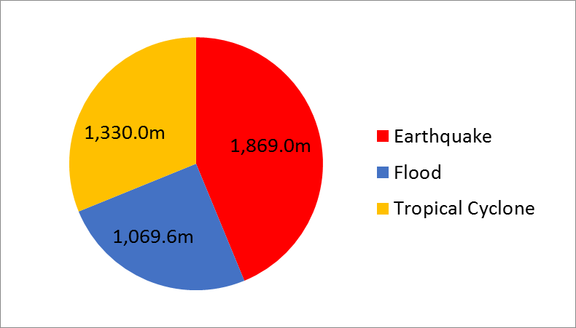
34 PDNAs
Figure A10.1 GPE PDNA education sector losses (USD 2016) by natural hazard.

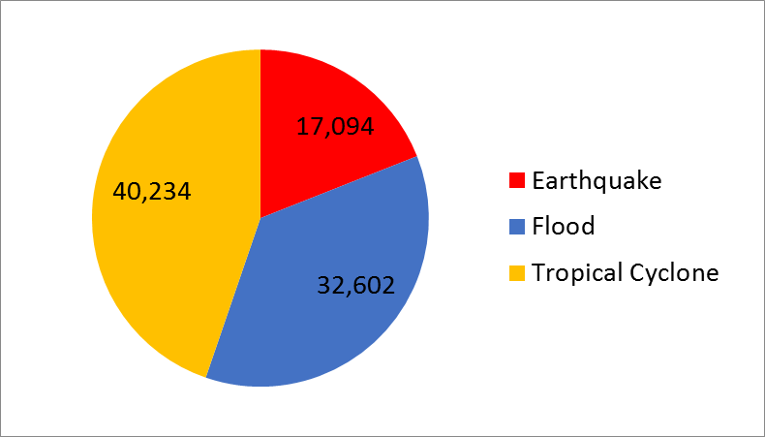
34 PDNAs
Figure A10.2 GPE PDNA number of schools affected by natural hazard.

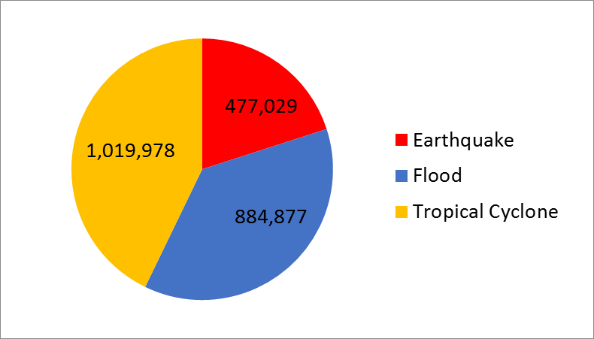
16 PDNAs
Figure A10.3 GPE PDNA number of children affected by natural hazard.

16 PDNAs

Figure A10.3 GPE PDNA number of children affected by natural hazard.

GPE (2017). Sustaining the Gains: Feasibility of Risk Financing for Education. Task 1 Report: Annexes). Willis Towers Watson, Start Network, Overseas Development Institute

Annex 3 Disruptions to Education

Table A3.1 Types of disruption to education systems.
Type of disruption | Definition/Examples
Disruption to the presence of students | Absenteeism caused by physical displacement of students or their withdrawal from school due to perceived risks, household economic needs etc. Alternatively, an influx of students due to refugee crises etc.
Disruption to the education delivery system | Reductions in education spending, foregone tuition / school fees, breakdown of systems, the loss of key personnel and records, emergence of complex needs in terms of curriculum content, language of instruction etc.
Disruption to the presence of the teaching workforce | Teacher death or injury, absenteeism caused by physical displacement of teachers or their withdrawal from school due to perceived risks, household economic needs etc.
Disruption to physical infrastructure | Looting, occupation, damage or destruction of classrooms, schools and learning materials etc.

Table A3.2 The impact and predictability of different types of shock on the education system. Source: Authors’ analysis
Shock | Predictability | Impact | Nature of disruption to education system
Earthquake | Low  (Overall risk quantifiable; onset, scale and location of events unpredictable; no warning) | Immediate | - Damage and destruction of school infrastructure  - Damage and destruction of learning materials  - Displacement of students  - Displacement / death of teachers
Flood / Tropical cyclone | Moderate  (Overall risk quantifiable; high risk areas can be identified; short-term – few hours to days – warning possible but usually vague) | Immediate | - Damage and destruction of school infrastructure  - Damage and destruction of learning materials  - Displacement of students  - Displacement / death of teachers
Epidemic illness | Low  (Overall risk not well quantified; onset, scale and duration unpredictable) | Slow onset / protracted | - Displacement / withdrawal of students  - Displacement / death of teachers  - Closure /alternative use of schools
Drought / famine | Moderate  (Overall risk broadly quantifiable; possible to identify early indicators, as well as likely affected groups and regions) | Slow onset / protracted | - Displacement / withdrawal of students  - Increase in malnutrition limits cognitive capacity of affected children  - Displacement / death of teachers
Civil unrest / violent conflict | Varied  (Overall risk not well quantified; possible to detect early warning signs or risk areas in some cases. Onset, scale and duration generally unpredictable) | Immediate | - Damage and destruction of school infrastructure  - Damage and destruction of learning materials  - Displacement / withdrawal of students  - Displacement / death of teachers
Prolonged insurgency | Moderate  (Overall risk not well quantified; possible to identify early indicators, as well as likely affected groups and regions) | Slow onset / protracted | - Occupation, damage and destruction of school infrastructure  - Damage and destruction of learning materials  - Displacement / withdrawal of students  - Displacement / death of teachers
Macro-economic shock | Varied  (Overall risk recognized but not well quantified; possible to identify early indicators, but scale and duration generally unpredictable) | Generally slow onset / usually protracted | - Lack of funds to maintain education program  - Displacement / withdrawal of students  - Displacement of teachers
Refugee influx due to shock in another state | Varied  (Overall risk not well quantified; likely to depend on the nature of the initial shock. Onset, scale and duration generally unpredictable) | Generally immediate, potential for slow onset / protracted | - Rapid increase in student numbers  - Emergence of additional and complex needs in terms of language, curriculum etc.  - Challenges in raising funds to expand education access

Annex 4 Quantifying the Costs of Restoring the Education System

A4.1 Short term costs
Table A4.1 Quantifying the costs of restoring the education system. Source: Data from Jones & Naylor (2014), Ndaruhutse and West (2015), Save the Children (2015) and data collected from Save the Children and the Start Network.
Type of cost | Method of estimation | Extent of existing data/ quantification | Example cost range per unit
Rebuilding of destroyed school building | Number of buildings destroyed x average cost of school building construction | Extensive | $35,000-$4.8 mn per school
Repairs to damaged school building | Number of buildings damaged x estimate of extent of damage x average costs of school building construction | Extensive | $13,000-$380,000 per school
Replacement of learning materials and equipment that were destroyed or looted | Estimate of cost of replacing lost equipment | Moderate | $5,000--$30,000 per school
Training of new teachers to replace those that left the teaching workforce due to death, disablement, trauma, displacement and recruitment to armed groups etc. | Number of teachers lost due to death, disablement, trauma, displacement and recruitment to armed groups x cost of teacher training | Extensive | $300-$8,825 per teacher
Pensions for teaching force due to disablement, trauma etc. | Number of teachers lost due to death, disablement and trauma x cost of teacher pension (where applicable) | Limited | None
Compensation to teachers or their families due to death, disablement, trauma etc. | Number of teachers lost due to death, disablement and trauma x cost of teacher compensation (where applicable) | Limited | None
Mediation to end school occupation | No of hours of staff time (usually cluster and MoE) supporting negotiations, through meetings, drafting of policy position, developing alternative solutions | Limited | $1,000-$2,000 of staff time
Breakdown of systems | Number of hours of staff time to rebuild systems, cost of replacing filing systems (online/paper) | Limited | $2,000 per MoE office
Loss of key personnel and records | Number of key personnel lost due to death, disablement and trauma x replacement costs (time-recruiting, training costs, loss of personnel time etc.) | Limited | $500 per staff member lost
Emergence of complex needs (e.g. curriculum reform) | Time to redraft, develop, print, distribute and disseminate new curriculum etc, | Limited | $10-$20 per textbook

Table A4.2 Quantifying the costs of foregone provision. Source: Government of Haiti (2010), Ndaruhutse and West (2015) & Save the Children (2015).
Type of cost | Method of estimation | Extent of existing data/quantification | Example cost range per unit
Falling government revenues/education spending | Will vary by shock. Current approaches based on empirical association between battle related deaths and reduced education expenditure. | Limited | 0.6%-11.4% reduction in annual public expenditure on education
Foregone tuition/school fees due to school closure, student absence etc. | Estimate of lost teaching days x average fee rate / day | Moderate | $0.75-$3.80 per student per lost teaching day

Table A4.3 Quantifying the costs of temporary education provision. Source: Overseas Development Institute (2016) and data collected from Save the Children and the Start Network.
Type of cost | Method of estimation | Extent of existing data/ quantification | Example cost range per unit
Provision of temporary structures | Number of temporary structures required x average cost of temporary structure construction | Extensive | $1,420 per 42 sq. m shelter
Provision of learning materials | Estimate of number of students lacking access to materials x per-pupil cost of learning material provision | Extensive | $4 per pupil (share of school-in-a-box)
Provision of teacher stipends | Number of teachers affected by shock conditions x estimated additional stipend required for retention | Extensive | $234-$2,600 per teacher, per annum
Provision of cash transfers/safety nets | Livelihoods assessment of Minimum Expenditure Basket x number of families requiring support | Limited | $102 per month for family of 5, including 3 children

A4.2 Long term costs

Table A4.4 Quantifying the long term costs of costs of shocks and disruption. Sources: Estimates from Jones and Naylor (2014), Mizunoya (2015) and Save the Children (2015).
Type of cost | Method of estimation | Extent of existing data/ quantification | Example of costs
Lower levels of educational achievement and learning outcomes due to lost teaching time from gaps in attendance / provision | Estimated reduction in national average years of schooling due to conflict x increase in income per capita for increase of one year in average years of schooling | Moderate – only for economic impact | DRC (2009-2012): $470 mn (1.5% of GDP)  Pakistan (2009-2012): $2.9 bn (1.3% of GDP)  Syria (2011-2015): $1.26 bn (3.1% of GDP)
Permanent reductions in cognitive ability due to persistent malnutrition | Estimated number of additional children affected by persistent malnutrition x loss in lifetime incomes associated with famine | Limited | $10.26 – $27.35 per annum per affected child
Permanent increase in out of school children | Estimate number of additional student drop-outs at different levels of education x wage differentials for wages for people with different levels of academic attainment, applied with discount rate | Moderate – only for economic impact | DRC (2009-2012): $53-107 mn  Pakistan (2009-2012): $440 mn – $1.5 bn  Syria (2011-2015): $2.18 bn – $10.7 bn

A4.3 Example: conflict shock impacts and costs

Table A4.5 Evidence from recent conflict disasters on the economic and social costs of shocks to the education system under the current approach.
 | DR Congo  (2009-2012) | Nigeria  (2009-2012) | Pakistan  (2009-2012) | Syria  (2011-2015)
Nature of crisis | Conflict | Conflict | Conflict | Conflict
Damage and destruction of school infrastructure | $20 mn | $4.95 mn | $23.63 mn | $991 mn – $2.73 bn
Damage and destruction of learning materials | $4 mn | $0.29 mn | $4.5 mn | $104 - $264 mn
Replacement of lost teachers | $2,100 | $20,000 | $115,020 | $2-$6 mn
Estimated loss from rise in OOSC due to conflict (range) | $53-$107 mn | Not available | $440 mn – $1.5 bn | $2.18 bn – $10.7 bn
Estimated loss from education disruption (loss of teaching days and learning outcomes) | $470 mn | Not available | $2.9 bn | $1.26 bn
Total cost estimate | $547 mn - $601 mn | $5.26 mn | $3.37 bn – $4.43 bn | $4.54 bn - $14.96 bn
Source | (Jones and Naylor, 2014) | (Jones and Naylor, 2014) | (Jones and Naylor, 2014) | (Mizunoya, 2015; Ndaruhutse and West, 2015; Save the Children, 2015)

A4.4 Example: natural disaster shock impacts and costs

Table A4.6 Evidence from recent natural disasters on the economic and social costs of shocks to the education system under the current approach.
 | Haiti  (2010) | Bangladesh  (2008) | Philippines  (2013) | Nepal  (2015)
Nature of crisis | Earthquake | Cyclone Sidr | Typhoon Haiyan | Earthquake
Damage and destruction of school infrastructure plus clean-up | $401.6 mn | $110 mn | $491.2 mn | $280.6 mn
Damage and destruction of learning materials | $82.3 mn
Lost tuition fees | $75.4 mn | Not available | $50.3 mn | $32.5 mn
Temporary schooling | $60 mn
Total cost estimate | $626.7 mn | $110 mn | $541.5 mn | $313.1 mn
Source | (Government of Haiti, 2010) | Government of Bangladesh (2008) | Government of the Philippines (2013) | (World Bank, 2015)

Annex 5 Impact of Early Financing and Response

Table A5.1 Evidence from recent conflict disasters on the economic and social costs of shocks to the education system under the current approach. (US$ Million)
 | DR Congo  (2009-2012) |  | Pakistan  (2009-2012) |  | Syria  (2011-2015)
 | Low | High | Low | High | Low | High
Infrastructure | 20 | 20 | 23.63 | 23.63 | 991 | 2,730
Teaching materials | 4 | 4 | 4.5 | 4.5 | 104 | 264
Replacement of lost teachers | 0.002 | 0.002 | 0.1 | 0.1 | 2 | 6
Loss from rise in OOSC | 53 | 107 | 440 | 1,500 | 2,180 | 10,700
Loss from education disruption | 470 | 470 | 2,900 | 2,900 | 1,260 | 1,260
Total crisis cost | 547 | 601 | 3,368 | 4,428 | 4,537 | 14,960
Total direct crisis cost | 24 | 24 | 28.25 | 28.25 | 1,097 | 3,000

Tables A5.2 – A5.5 present the potential savings from reductions in direct costs from early financing and response for the conflicts presented in Table A5.1. It is important to note that in these tables we assume that the cost of insurance is equal to the direct cost of the crisis (i.e. the cost of replacing lost infrastructure, teaching materials and teachers). Thus, although these costs will be compensated for by the insurance pay out they are are not classified as savings here, as they have already been paid for by insurance premiums etc. Savings estimates are therefore derived entirely from reductions in the costs associated with foregone education and rising numbers of out of school children.

Table A5.2 Cost savings scenario based on a 5% reduction in the education response gap (US$ Millions). Source: Authors calculations.
 | DR Congo  (2009-2012) |  | Pakistan  (2009-2012) |  | Syria  (2011-2015)
 | Low | High | Low | High | Low | High
Loss from rise in OOSC | 2.65 | 5.35 | 22 | 75 | 109 | 535
Loss from education disruption | 23.5 | 23.5 | 145 | 145 | 63 | 63
Total cost savings | 26.15 | 28.85 | 167 | 220 | 172 | 598
Savings as proportion of total crisis cost | 4.8% | 4.8% | 4.96% | 4.97% | 3.79% | 4%
Savings as proportion of direct crisis cost | 109% | 120.2% | 591.26% | 778.89% | 15.7% | 19.9%

Table A5.3 Cost savings scenario based on a 10% reduction in the education response gap (US$ Millions). Source: Authors calculations.
 | DR Congo  (2009-2012) |  | Pakistan  (2009-2012) |  | Syria  (2011-2015)
 | Low | High | Low | High | Low | High
Loss from rise in OOSC | 5.3 | 10.7 | 44 | 150 | 218 | 1,070
Loss from education disruption | 47 | 47 | 290 | 290 | 126 | 126
Total cost savings | 52.3 | 57.7 | 334 | 440 | 344 | 1,196
Savings as proportion of total crisis cost | 9.56% | 9.6% | 9.92% | 9.94% | 7.58% | 8%
Savings as proportion of direct crisis cost | 217.9% | 240.4% | 1182.5% | 1557.8% | 31.36% | 39.87%

Table A5.4 Cost savings scenario based on a 25% reduction in the education response gap (US$ Millions). Source: Authors calculations.
 | DR Congo  (2009-2012) |  | Pakistan  (2009-2012) |  | Syria  (2011-2015)
 | Low | High | Low | High | Low | High
Loss from rise in OOSC | 13.3 | 26.8 | 110 | 375 | 545 | 2,675
Loss from education disruption | 117.5 | 117.5 | 725 | 725 | 315 | 315
Total cost savings | 130.8 | 144.25 | 835 | 1,100 | 860 | 2,990
Savings as proportion of total crisis cost | 23.9% | 24% | 24.8% | 24.8% | 19% | 20%
Savings as proportion of direct crisis cost | 544.7% | 600.9% | 2956.3% | 3894.5% | 78.4% | 99.7%

Table A5.5 Cost savings scenario based on a 50% reduction in the education response gap (US$ Millions). Source: Authors calculations.
 | DR Congo  (2009-2012) |  | Pakistan  (2009-2012) |  | Syria  (2011-2015)
 | Low | High | Low | High | Low | High
Loss from rise in OOSC | 26.5 | 53.5 | 220 | 750 | 1,090 | 5,350
Loss from education disruption | 235 | 235 | 1,450 | 1,450 | 630 | 630
Total cost savings | 261.5 | 288.5 | 1,670 | 2,200 | 1720 | 5,980
Savings as proportion of total crisis cost | 47.8% | 48% | 49.6% | 49.7% | 37.9% | 40%
Savings as proportion of direct crisis cost | 1089.5% | 1202% | 5912.6% | 7789% | 156.8% | 199.3%

From original analysis of EM-DAT (http://www.emdat.be/) data
Tropical cyclone, earthquake and flood
From original analysis of 34 PDNAs in GPE partner countries. This estimate likely represents 60% of overall natural disaster losses to education.
For EM-DAT data on the total number of events in GPE countries between 2000 and 2016 by hazard, see Annex 2. Absolute numbers of events mirror hazard distribution by GPE country.
Range based on school construction estimates for Pakistan in Jones and Naylor (2014) and World Bank PDNA estimates for the Seychelles.
Range based on World Bank PDNA school repair cost estimates data for Myanmar and Fiji.
Range based on generic estimate from Jones and Naylor (2014) and estimates for Syria in Ndaruhutse and West (2015).
Range based on estimates from the DRC in Jones and Naylor (2014) and from Syria in Ndaruhutse and West (2015).
Lai and Thyne (2007) found that being in a state of civil war is associated with a 3.1-3.6% reduction in education expenditure per year. Further analysis based on the severity of the conflict found that an increase of 1,000 battle related deaths per year leads to a reduction in BRDs per year leads to a reduction in educational expenditure of about 2–2.7%.
Range based on the application of the approach of Lai and Thyne (2007) to data on the Democratic Republic of the Congo and Pakistan (Jones and Naylor, 2014). Similar estimates have not yet been produced for non-conflict shocks, but should be considered a future priority.
Range based on daily fee at Omega Schools (low fee private schools) in Ghana and the maximum monthly fee that can be charged by private-subsidised schools in Chile.
Sources for ECW estimates: UNICEF Supply Catalogue (temporary learning areas and education materials); Theunynck (2002) (teacher stipend/salaries); and DFID (2011) (teacher training). See ODI (2016) for full details of calculations.
Assumption of 40 students per school-in-a-box kit.
Class sizes at different levels of education assumed to be as follows: Pre-Primary 26; Primary 35; Lower Secondary 27; Upper Secondary 23 (Education for All Global Monitoring Report, 2015).
Based on costs for Save the Children programme in Lebanon.
Indicative calculations for in-utero and infant children during the 1984 Ethiopian famine suggest income losses of between 3% and 8% per year over their lifetime (Dercon and Porter, 2014).
Based on the estimates in Dercon and Porter (2014), combined with GDP per capita in Ethiopia in 2010 (current US$)(World Development Indicators).
Government of Haiti (2010). Haiti Earthquake, Post-Disaster Needs Assessment.
Government of Bangladesh (2008). Cyclone Sidr in Bangladesh: Damage, Loss and Needs Assessment for Disaster Recovery and Reconstruction
Government of the Philippines (2013). Reconstruction Assistance on Yolanda.
World Bank (2015). Nepal Earthquake, Post-Disaster Needs Assessment. Working Paper 97501.
Source – DR Congo, Nigeria and Pakistan – Jones and Naylor (2014). Syria – Mizunoya (2015); Ndaruhutse and West (2015); and Save the Children (2015).
Note – direct crisis costs here and below refers to (i) the costs of replacing infrastructure and teaching materials and (ii) the costs of replacing lost teachers.

