Request for Information

Coding Project Budgeting Tool

Save the Children

8th May 2017

Introduction

Save the Children exists to help children affected by crises, or those who need better healthcare, education and protection. We work on the ground, and we campaign to secure positive change.

Save the Children believes every child deserves a future. Around the world, we give children a healthy start in life, the opportunity to learn and protection from harm.
We do whatever it takes for children – every day and in times of crisis – transforming their lives and the future we share. We reach over 55 million children directly through our and our partners' work in over 60 countries.

As a key component of our ability to deliver help to children, our finance function allows transparency and accountability to both donors and beneficiaries.

Save the Children International is currently involved in several initiatives to realise the strategic goal of becoming a High Performing Organisation. The proper operation of the movement’s finance function is pivotal to this goal.

The Coding Project is seeking to identify and remediate pain points in the way the organisation records and reports expenditure at every level. Fundamental to this are the tools and processes used to budget effectively for the delivery of programmes to our beneficiaries.

At present, the organisation’s budgeting practices lack centralised control and standardisation, compromising data integrity and leading to poor reporting and reputational damage.

As such, the Coding Project is aiming to design and implement an organisation-wide system tool to allow budget holders and finance staff to create, maintain, and approve budgets in a standardised way across the globe.

Thank you for your interest in supporting SCI with this important initiative.
Regards
Dearta Fusaro
Coding Project Lead

Part 1 – BACKGROUND

Core Scope of RfI

Save the Children would like to seek input on technology that will better allow our organisation to create, update and maintain budget data. Currently these are ad-hoc activities with varied process and governance across our organisation’s groups. This technology will form the basis of a global solution that allows users to create new budgets from within Save the Children’s core systems (AMS), view and manage all budget data in (as close to possible) real time. The tool will also adhere to the organisation’s workflow hierarchies and integrate with several core systems.

We foresee the solution(s) being a key enabler in helping our organization in the areas of financial data integrity and increased transparency and accountability for spend. This market exercise forms parts of Save the Children’s overall financial transformation strategy.

Supplier Response

Suppliers must adhere to the structure outlined in the section titled “Submission of Response” within this document. Where questions cannot be answered fully, please provide a relevant explanation and details.

Please keep responses concise and, where practical, include electronic links to where additional relevant information can be found.

A pitch or presentation style document is welcomed, please do not PDF your response and questions should be answered in English.

Outline Timetable
Set out below is the proposed timetable. This is intended as a guide and whilst SCI does not intend to depart from the timetable it reserves the right to do so at any stage.

Target Date | Activity
8th May 2017 | RFI published
15th May 2017 | Confirmation of interest to participate
17th May 2017 | All clarification questions to be submitted
23rd May 2017 | Submission deadline

If Save the Children wish to find out further information on your response, an invitation for a presentation maybe requested.
Due to the anticipated level of responses it is unlikely that everyone will have the opportunity to present. This is not a reflection of your response and this RfI is solely an information gathering exercise.

Submission Process

Responses to this RFI are due by Tuesday 23rd May to dearta.fusaro@savethechildren.org. If you have any questions in the meantime, please contact caroline.aston@savethechildren.org via email.

Supplier Contact Point
Potential providers are asked to include a single point of contact in their organisation. Save the Children will not be responsible for contacting potential providers through any route other than the nominated contact.

Considerations
- This RFI is only a fact-finding exercise to assess the capabilities in the market.
- There is no obligation for Save the Children to contract for any of the products or services described in the RFI responses. SCI reserves the right to re-bid all or parts of the services detailed in this RFI. Suppliers will not be reimbursed for any costs they incur in preparing their RFI responses.
- By submission of the response, the supplier warrants that: the prices in the response have been arrived at independently, without consultation, communication, agreement or understanding for restricting competition, as to any matter relating to such prices, with any other supplier or with any competitor. Unless otherwise required by law, the supplier has not knowingly disclosed the prices that have been quoted in their response, directly or indirectly, to any other supplier or competitor, nor will they be so disclosed.

Definitions

The following table provides definitions for some key terms referenced in this document:

System | Description
Activity | An activity is a measurable amount of work (task) performed to convert inputs into outputs. An activity would be the smallest unit of work in a project. Often used as an alternative term for task
AMS | Award Management System – online system to capture and manage all data and workflow relating to the lifecycle of an Award
Award | All contributions that SCI receives to deliver both its humanitarian and development programmes for children, including grants, contracts, member undesignated funds and gift in kind (GIK) donations
Donor Report Code (DRC) | A line in an Award budget which needs to be reported to a donor
Funding Office | The logical organisational unit that is responsible for providing funding for an Award
Implementing Office | The logical organisational unit that is responsible for implementing an Award/Project
Partner | Organisation with a mutually agreed set of principles and accountabilities that contributes to implementing an Award/Project
Project | A set of Activities meeting agreed objectives, in a specific period of time and with an agreed set of resources

Logical Data Model

The following is a high level, logical organisational data model for how the relevant data entities relate to each other in regard to Award budgeting. In reality this is more complicated but is simplified here to give an indicative, contextual view.

Requirements for the Budgeting Tool

The below table outlines the current functional requirements for the Budgeting Tool. As per Save the Children’s IT methodology, these requirements are presented as user stories.

This does not represent an exhaustive view of requirements and is provided only for indicative purposes.

User Profiles
The following simple personas have been used to map user stories to. Each persona will nominally map to 1 or more actual roles but are aggregated for simplicity and to capture the logical intent of the user the story is related to.

Entity | User Profile
Budget Creator | User responsible for creating, initiating a proposal budget
Budget Editor | any user involved in development of the detailed budget
Budget Viewer | any user who should have access to view a budget and related information
Budget Owner | designated owner of the budget (e.g. Budget Holder)
Donor Manager | user designated to manage a Donor relationship and related information

Category | ID # | Requirement
Budget Creation/Initiation | 1 | As a Budget Creator, I can create/initiate a new budget from the Awards Management System so that the context and data of the related Award can be linked to the budget, including:  Award Id, Award Name, Award amount, Donor, funding office, implementing office, currencies, budget holder
 | 2 | As a Budget Creator I can link a budget to a Project Entity (from the Project Management System) so that I can budget for costs against the project and dimensions of the Project including:  Project Id, Project Name, Project Activities
 | 3 | As a Budget Creator I can link a budget to 1 or more standard Awards so that I can work with a single budget for projects that are funded by multiple awards
 | 4 | As a Budget Creator, when I create a budget I am prompted to enter initialisation data (if desired) so that it can save time and effort in later parts of budget development  e.g.  - Locations the award/project is to be implemented  - Themes related to the project  - Transaction currencies to be used in development of the budget (defaulted to implementing office transactional currency)
 | 5 | As a Budget Creator, when creating a new budget, a default set of budget lines (required for all budgets) are automatically included in the budget so that required costs can be accounted/budgeted for
 | 6 | As a Budget Creator, when creating a new budget, I am prompted to generate a default list of Donor Report Codes (and chapters) for the related Donor (if available) so that I don't have to manually enter this data every time
 | 7 | As a Budget Creator, when creating a new budget, I am able to select from a list of ‘budget templates’ to generate a default list of budget lines so that I can save time when building the budget detail  e.g. budgeting templates for common project types e.g. ‘malaria prevention’
 | 8 | As a Budget Creator, I can manage the phasing periods (years) of the budget so that I can reference them when developing the budget detail (phasing)
 | 9 | As a Budget Creator, I want relevant exchange rates from the finance system automatically imported/available to be used in translating transaction and donor currencies so that I do not have to manually enter exchange rates
 | 10 | As a Budget Creator, I want the option to use a manual exchange rate so that I can budget against pre-agreed donor exchange rates
Budget Summary View | 11 | As a Budget Viewer, I want to see a 'summary dashboard view' of the budget so that I can see an aggregated/rolled up view of different aspects of the budget data.
 | 12 | As a Budget Viewer, on the 'summary dashboard view' I can see core information for the related Project and Awards (Title, Dates, Locations, Partners, Donors, Award Amounts) so I can get a quick overview of what the budget is related to
 | 13 | As a Budget Viewer, on the 'summary dashboard view' I can see a breakdown of budget amounts by Location (derived from detailed budget data) in Transaction, Donor and Base currency so that I can understand how the budget will be spent geographically
 | 14 | As a Budget Viewer, on the 'summary dashboard view' I can see a breakdown of budget amounts by Activity (derived from detailed budget data) in Transaction, Donor and Base currency so that I can understand how the budget will be spent by Activity
 | 15 | As a Budget Viewer, on the 'summary dashboard view' I can see a breakdown of budget amounts by Theme, x-cutting (derived from detailed budget data) in Transaction, Donor and Base currency so I can see at a glance how the budget is being distributed by theme
 | 16 | As a Budget Viewer, on the 'summary dashboard view' I can see an indicator to show where budget data is not complete or consistent e.g. where total award amounts do not equal phasing amounts so that I can quickly navigate to areas of the budget that require input
Detailed Budget Development | 17 | As a Budget Editor, I can use a 'detailed budget view' so that I can view and input detailed budget data as required
 | 18 | As a Budget Viewer, I can view the 'detailed budget view' with detailed budget lines grouped by related Activity (or other related metadata for a budget line) so I can understand the structure of the project/award I am building the budget for and see summarised information for those activities, including:  - Name of the Activity  - Total budget amount for the activity (calculated) in transaction, donor and base currencies  - other direct attributes of the Activity
 | 19 | As a Budget Editor I can add 'detailed budget lines' to an Activity so that I can capture required budget information, including total costs for:  - Location/Partner the budget line relates to  - 'Budget calculation fields' to calculate the total item cost (quantity, unit, number of units, cost per unit)  - % committed by donor
 | 20 | As a Budget Viewer, I can clearly distinguish which budget lines are to be implemented by Partners as opposed to the implementing office so that I can understand the nature of budget costs
 | 21 | As Budget Editor I can add notes to a detailed budget line so that I can inform other budget stakeholders of required action or review
 | 22 | As a Budget Viewer, I can view notes that other users have created for detailed budget lines so that I can understand contextual detail for a budget line
 | 23 | As a Budget Viewer, I can change the grouping of the 'detailed budget view' so that I can view and analyse the budget in different dimensions e.g by Location -> Activity -> Detailed Budget Lines
 | 24 | As a Budget Editor I can expand the 'detailed budget view' to show a 'financial coding view' so that I can view and enter additional financial coding data for each budget line, including:  - Account code and description  - Cost Centre code and description  - DRC Code and description  - Analysis code and description
 | 25 | As a Budget Editor, when I enter data in the 'financial coding view', data is validated against up to date codes from the financial management system so that I am informed of any incorrect or invalid codes or combinations
 | 26 | As a Budget Editor, I can enable a 'detailed budget phasing view' so that I can view and edit budget amounts over phases/years for the related awards
 | 27 | As a Budget Editor, I can enter phasing budget data by month for the first year of the award so that this information can be used in later parts of the budgeting lifecycle
 | 28 | As a Budget Editor, I can add notes to the budget as a whole so that other budget viewers can be notified of comments/details I feel are important
 | 29 | As a Budget Editor, I can export my budget to Excel so that I can do further custom analysis and view my budget offline if I need
 | 30 | As a Budget Editor I want changes I make to be versioned so that I can compare and analyse previous changes to the budget data
 | 31 | As a Budget Editor, I can import partner budget lines using a pre-defined template so that I can incorporate detailed partner costs into my budget
 | 32 | As a Budget Editor, on the 'detailed budget view' I can see a summary figure for the total budget amount in transactional, donor and base currencies
 | 33 | As a Budget Editor, on the 'detailed budget view' I can see a summary figure for the gap budget amount (the amount for budget lines that have not been associated with an award) in transactional, donor and base currencies
Donor/Proposal Budget | 34 | As a Budget Editor, I can see a 'proposal budget checklist' to support me in the proposal budgeting process so that I can be sure I have covered required costs
 | 35 | As a Budget Viewer, I can see a 'donor view' to see budget data aggregated by Donor Report Codes/Chapters so that I can understand how the costs are broken down for donor needs.
 | 36 | As a Budget Editor I can create and update Donor Reporting Codes (DRC's) so that they can be associated with detailed budget lines in the in the 'detailed budget view'
 | 37 | As a Budget Owner, I can generate a proposal budget by selecting a pre-defined template from either a set of generic proposal templates/formats or a format/template related to the related donor so that I do not have to create and format a specific document manually
Donor Management | 38 | As a Donor Manager I can manage Donor related budget information like sets of default Donor Reporting Codes and Chapters so that they can be used for all budgets involving that Donor
 | 39 | As a Donor Manager I can manage Donor Proposal Templates for specific donors that can be used to generate Proposal budgets automatically in the required donors format
Security, Workflow and System Integration | 40 | As a Budget Owner I can restrict budget access to be secured based on a permissions structure related to the attributes of the related award/projects so that only required staff have access to view the detailed budget information
 | 41 | As a Budget Owner, I want to automatically feed budget data into the financial management system when required e.g. Based on workflow or a specific action
 | 42 | As a Budget Owner I want the ability to submit budgets for approval through online workflows so that budgets can be approved by users with appropriate authority before budget data is pushed to Agresso (financial management system)
Review, Forecast and Amendments | 43 | As a Budget Holder I can view actual spend data against my budget from Agresso (financial management system) as close to real time as possible so that I can make informed decisions regarding my budget
 | 44 | As a Budget Editor I can create forecasts so that I can provide updated budget data for future budget periods without having to manually upload changes from a file
System/Non Functional | 45 | As a Budget Viewer I can access the system using my organisational Azure Active Directory credentials so that I do not have to remember a different username/password combination to access the system
 | 46 | As a Budget Viewer, I can access the system using a standard web browser (IE Edge, Chrome, Firefox) so that I do not need any special software installation to work on a budget
 | 47 | As a Budget Viewer I can access the system in low bandwidth scenarios (min 50kbps) so that I can work on my budget even in areas where internet is slow or not reliable
 | 48 | As a Budget Viewer I can set the system language to one of (English, French, Spanish, Arabic) so that I can use the system more effectively in my local language
 | 49 | As a Budget Viewer I can access the system at the same time as up to 1000 potential concurrent users

Enterprise Systems Integration

The budgeting solution will need to integrate with the following SCI line of business systems:

System | Description
Agresso | Global Financial System  Vendor: Unit4  On Premise hosted
AMS | Global Award Management System  Custom built application, cloud hosted on Microsoft .Net, SQL Server 2014 technology
Project Management | Global Project Management System – Technical details TBC

The following is a high level view of how the budgeting solution will need to integrate with existing systems:

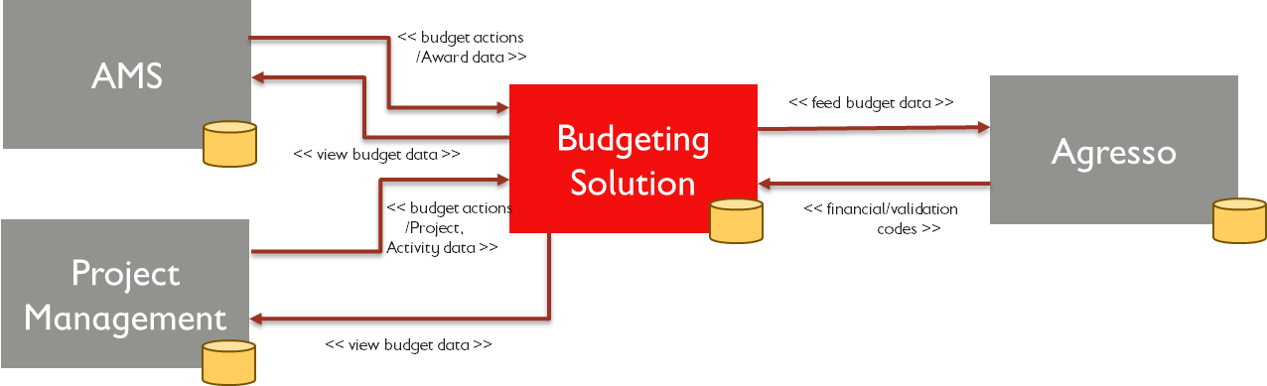

Submission of Response:

Provide a response to the below questions; the requested format of response is:

1. PowerPoint or Word with details of your responses to the questions below
2. Excel template completed outlining commercials and capability overview (included below)

Please find below the mandatory areas to cover for participation in the Save the Children Budgeting Tool RfI.

Business Activities
- Company introduction
- Commercials and capability overview (please fill in attachment)
- What is your global footprint in relation to Save the Children’s operations, outlined in Appendix A? Please complete the Capability Overview tab within?
- Please specify how you would host solutions serving these countries to address issues such as bandwidth.

Market Perspective & References
- What elements of the market represent the current growth areas and your perceived current strengths?
- Details of experience integrating to Unit 4 – Agresso and / or other line of business applications
- Detail your experience of delivering similar services within the NGO and Charity Sector as well as in other sectors to a similar level of complexity and scale/footprint
- Please provide details of at least two references

Proposed Solution

Please provide a proposed solution of how you would deliver meet our requirement in relation to the scope areas outlined. As part of your answer please include:

- A proposed solution of how you would deliver against the requirements
- Given the user profile, pain points outlined and your knowledge of the NGO/Charity sector, outline the sequence of implementation by scope area.
- Relevant case study which demonstrates a successful example of your product, including integration between multiple systems
- Outline details of your service in relation to data integrity and hosting
- An illustrative user interface design

As part of your answer please update Attachment 1 to include:
- Different price models that can be used in the market to undertake this work along with a recommendation and indicative timelines for implementation
- How you will deliver our design principles outlined in Appendix B

Support Model
- Please provide details on options and costs for the following services:
  - Training (around go-live and ongoing)
  - System Administration
  - Configuration / ongoing improvements
  - First line support
  - Second line support
  - Upgrades

Success Criteria
- Details of expected engagement with client (provision of business owner / product owner etc.)
- Please least the top 5 critical success factors and your solutions / methods to:
  - An on-time, to budget implementation (5 CSFs)
  - Maximising user adoption / user experience (5 CSFs)

Commercial Model
Please detail the optimum commercial arrangement for an engagement of this type. As part of your response please include:
- How do you control cost and demonstrate value for money?
- What is the optimum contracting model?
- How would you support growth in user base over the next 5 years?
- Based on the core and extended scope areas please provide your cost estimate on the attached excel on the Tab “Price Breakdown”?
- The “Alternative Pricing” tab has been left blank to provide you with the option to suggest alternative price models alongside, the required price breakdown.
- If asked to deliver the scope would you partner with other organisations? If so, who are your strategic partners for solution, implementation and delivery (change management and advisory support) how would this relationship work?

Please include all figures in US Dollars. All systems should support SCI’s main languages English, Spanish and French as part of the operations. Please split out system costs, implementation, and post-go-live support.

Innovation
- What innovations has your organisation pioneered in the last three years in the market place?
- What is your organisation’s roadmap for the next three-five years?

APPENDIX A – SCI’s Global Footprint 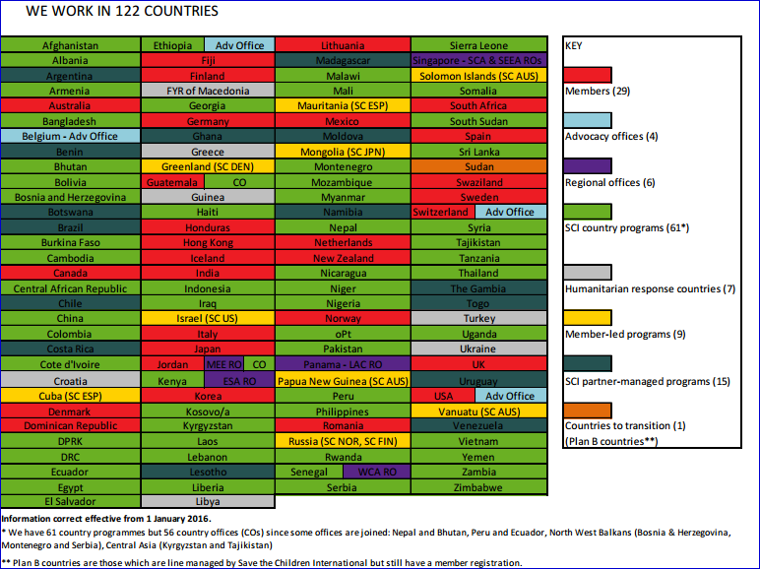

APPENDIX B – SCI IT Design Principles
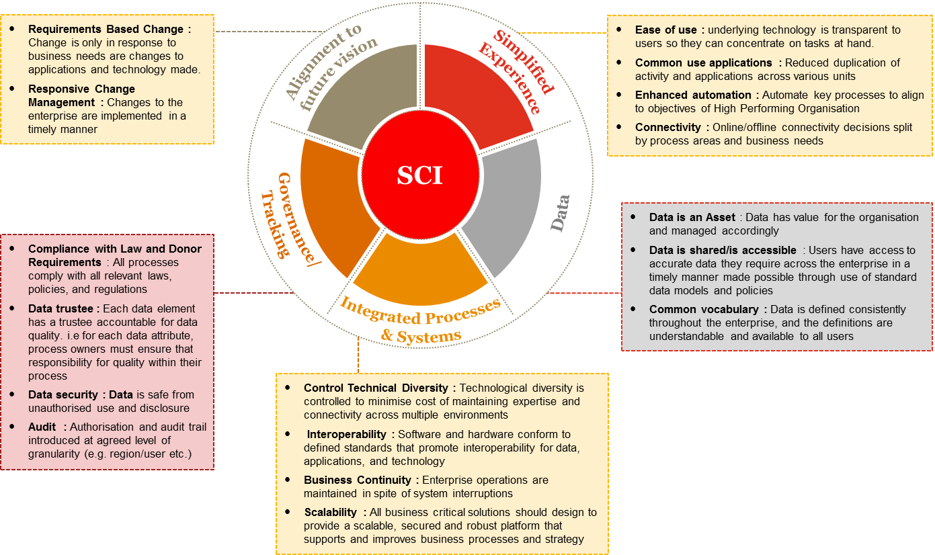

Attachments

No. | Attachment Name | Attachment
1 | Commercial Input and Capability Overview

PART 2: SAVE THE CHILDREN’S CHILD SAFEGUARDING POLICY
Our values and principles
Child abuse is when anyone under 18 years of age is being harmed or isn't being looked after properly. The abuse can be physical, sexual, and emotional or neglect. The abuse and exploitation of children happens in all countries and societies across the world. Child abuse is never acceptable.
It is expected that all who work with Save the Children are committed to safeguard children whom they are in contact with.
What we do
Save the Children is committed to safeguard children through the following means:
Awareness: Ensuring that all staff and those who work with Save the Children are aware of the problem of child abuse and the risks to children.
Prevention: Ensuring, through awareness and good practice, that staff and those who work with Save the Children minimise the risks to children.
Reporting: Ensuring that you are clear on what steps to take where concerns arise regarding the safety of children.
Responding: Ensuring that action is taken to support and protect children where concerns arise regarding possible abuse.
To help you clarify our safeguarding approach, we list here examples of the behaviour by a representative of Save the Children which are prohibited. These include but are not limited to:
- Hitting or otherwise physically assaulting or physically abusing children.

- Engaging in sexual activity or having a sexual relationship with anyone under the age of 18 years regardless of the age of majority/consent or custom locally. Mistaken belief in the age of a child is not a defence.

- Developing relationships with children which could in any way be deemed exploitative or abusive.

- Acting in ways that may be abusive in any way or may place a child at risk of abuse.
- Using language, making suggestions or offering advice which is inappropriate, offensive or abusive.

- Behaving physically in a manner which is inappropriate or sexually provocative.
- Sleeping in the same bed or same room as a child, or having a child/children with whom one is working to stay overnight at a home unsupervised.

- Doing things for children of a personal nature that they can do themselves.

- Condoning, or participating in, behaviour of children which is illegal, unsafe or abusive.

- Acting in ways intended to shame, humiliate, belittle or degrade children, or otherwise perpetrate any form of emotional abuse.

- Discriminating against, showing unfair differential treatment or favour to particular children to the exclusion of others.

- Spending excessive time alone with children away from others.

- Placing oneself in a position where one is made vulnerable to allegations of misconduct.
In order that the above standards of reporting and responding are met, this is what is expected of you:
If you are worried that a child or young person is being abused or neglected, (such as in points 1, 2, 3, 4, 6, 8, 9 and 10 above for example) or you are concerned about the inappropriate behaviour of an employee, or someone working with Save the Children, towards a child or young person, then you are obliged to:
- act quickly and get help
- support and respect the child
- where possible, ensure that the child is safe
- contact your Save the Children manager with your concerns immediately (or their senior manager if necessary)
- keep any information confidential to you and the manager.
If you want to know more about the Child Safeguarding Policy then please contact your Save the Children manager.

PART 3: SAVE THE CHILDREN’S ANTI-BRIBERY AND CORRUPTION POLICY

Our values and principles
Save the Children does not allow any partner, supplier, sub-contractor, agent or any individual engaged by Save the Children to behave in a corrupt manner while carrying out Save the Children’s work.
What we do
Save the Children is committed to preventing acts of bribery and corruption through the following means:
Awareness: Ensuring that all staff and those who work with Save the Children are aware of the problem of bribery and corruption.
Prevention: Ensuring, through awareness and good practice, that staff and those who work with Save the Children minimise the risks of bribery and corruption.
Reporting: Ensuring that all staff and those who work with Save the Children are clear on what steps to take where concerns arise regarding allegations of bribery and corruption.
Responding: Ensuring that action is taken to support and protect assets and identifying cases of bribery and corruption.

To help you identify cases of bribery and corruption, behaviour which amounts to corruption includes but is not limited to:
  - Paying or Offering a Bribe – where a person improperly offers, gives or promises any form of material benefit or other advantage, whether in cash or in kind, to another in order to influence their conduct in any way.

  - Receiving or Requesting a Bribe – where a person improperly requests, agrees to receive or accepts any form of material benefit or other advantage, whether in cash or in kind, which influences or is designed to influence the individual’s conduct in any way.

  - Receiving or Paying a so-called ‘Grease’ or ‘Facilitation’ payment – where a person improperly receives something of value from another party for performing a service or other action that they were required by their employment to do anyway.

  - Nepotism or Patronage – where a person improperly uses their employment to favour or materially benefit friends, relatives or other associates in some way. For example, through the awarding of contracts or other material advantages.

  - Embezzlement - where a person improperly uses funds, property, resources or other assets that belong to an organisation or individual.

  - Receiving a so-called ‘Kickback’ Payment – where a person improperly receives a share of funds, a commission, material benefit or other advantage from a supplier as a result of their involvement in a corrupt bid or tender process.

  - Collusion – where a person improperly colludes with others to circumvent, undermine or otherwise ignore rules, policies or guidance.

  - Abuse of a Position of Trust – where a person improperly uses their position within their organisation to materially benefit themselves or any other party.

In order that the above standards of reporting and responding are met, this is what is expected of you:
You have a duty to protect the assets of Save the Children from any form of corruption. Furthermore, you must immediately report any suspicion of bribery or corruption to the Save the Children senior management team or Country Director and not to anyone else. Failure to report will be treated as serious and may result in termination of any agreement with Save the Children.
You are obliged to:-
- act quickly and get help
- encourage your own staff to report on bribery and corruption
- contact the Save the Children senior management team or Country Director with your concerns immediately (or their senior manager if necessary)
- keep any information confidential to you and the manager.
Attempted corruption is as serious as the actual acts and will be treated in the same way under this policy.

If you want to know more about the Anti-Bribery and Corruption Policy then please contact your Save the Children representative.

