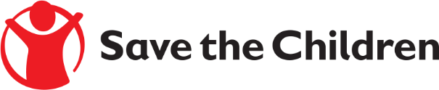

Request for Quotation Notice

Save the Children believes every child deserves a future. Around the world, we give children a healthy start in life, the opportunity to learn and protection from harm. We do whatever it takes for children – every day and in times of crisis – transforming their lives and the future we share.

Save the Children International is inviting submissions of quotations for the services of a Responsible Person to be named on our Wholesale Dealer Authorisation (h), issued by the Medicines and Healthcare Regulatory Authority.

Detailed Terms of Reference are included within the Request for Quotation documents.

If you are interested in submitting a bid, please contact Sarah Watson at the following address sarah.watson@savethechildren.org to express your interest and request the Request for Quotation documents. Request for Quotation documents will be sent to you by return.

It is recommended to request the Request for Quotation documents as soon as possible.

Completed documents are due to be submitted by 13th March 2019 at 5pm GMT.

