Terms of Reference

Study: Girls on the Move in Egypt, Ethiopia and Sudan – Qualitative Primary Research to Support the Protection of Girls and Young Women in Vulnerable Displacement Situations.

1. Background: Children on the move in East and the Horn of Africa

The last decade has seen a dramatic increase in the global mobility of people. The number of people globally who live outside of their country of birth had reached 258 million by late 2017. Irregular migrants from the Global South, often not captured in official data, are of particular concern from a development and humanitarian perspective: they are often amongst the most vulnerable populations. Internationally, children constitute approximately 15% of migrants. This proportion is dramatically larger in East and Southern Africa, where 28.2% of recorded migrants are children.
Within the target countries of this project, Egypt, Ethiopia and Sudan, data from 2018 highlights increased levels of population movements to and within Ethiopia, with internal displacement and increasing movement of Eritreans into the country driving this increase. From the end of 2017 to June 2018, the number of IDPs in Ethiopia increased from nearly 1.1M to 1.4M persons with around 35,000 more refugees and asylum seekers registered, for a total of 928,663. Sudan is host to nearly 2M IDPs and nearly 1M refugees and asylum seekers, largely from South Sudan, but also comprising of over 100,000 Eritreans. With 230,000 refugees, Egypt has by far the smallest population of concern. There are only small numbers of Egyptians migrating to Europe and no departures emanating from the country. Egypt’s ability to effectively curb migration to Europe has resulted in the European Union’s desire to promote the ‘Egypt Model’ in spite some concerns about the conditions of refugees in the country.
Following the reopening of the border crossing points between Eritrea and Ethiopia, the number of Eritreans coming to Ethiopia has increased significantly, with over 9,900 newly registered Eritrean refugees only between the 3rd – 12th October 2018, over 77% being below the age of 24 years. Within Ethiopia, there are an increasing number of unaccompanied child migrants and reports indicate that the death of one or both of parents, the separation or remarriage of a parent, abuse or violence within home (including issues of child marriage) and/or domestic disputes within the household are among the push factors for children to migrate. Conflict continues to be another key driver of displacement, with 700,000 people having been displaced from Oromia and SNPP communities since April 2018.
Although there has been a decrease in the number of migrants arriving to Europe from East Africa, Eritreans continue to be significantly represented amongst those arriving in Italy, second only to Tunisians. Migrants and refugees from Sudan have been the third highest arrival group in Italy thus far in 2018. There were 751 Sudanese migrants arriving to Italy by sea in June 2018, which was an increase from 201 in May, in addition to 1,628 Sudanese migrants who were intercepted at sea by the Libyan coast guard in the first half of 2018.
Child and youth migration is historically linked to stages of societal and economic development in Africa. Save the Children recognises that safe migration can be an important avenue for realising individual aspirations and enabling access to education or decent work. However, children who migrate alone are vulnerable to a variety of risks, including physical and sexual violence, harmful work, and foregoing the very services they have migrated to access in the first place. In many countries in East and Southern Africa clear child protection legislation is in place, but often it is only implicitly and by extension protecting migrant children, failing to recognize their specific risks.

2. East African Migration Routes Project

Save the Children, in implementing a four-year project funded by the Swiss Agency for Development and Cooperation (SDC), focuses on improving the protection of children on the move (and children to migration) in three focus countries: Egypt, Ethiopia and Sudan, starting from the main urban centres (Addis Ababa, Cairo and Khartoum) over to broader migration routes and relevant refugee and migrants’ hubs.

The 14 months Inception Phase (2019-2020) of the project focuses on piloting test activities, developing detailed programme implementation plans, establishing baselines, and conducting four key research/study outputs:
- Conflict sensitivity audit of planned intervention strategy
- Mapping of existing child protection initiatives and partners
- Study on gender in displacement situations
- Political economy analysis of migrant flows
- Country level baselines studies

The three-year Implementation Phase (2020-2023) of the project has four main Outcomes:
- Children and youth in vulnerable situations have their rights respected and possess sound self-reliance capacities that allow them to improve their life perspectives.
- National and community organizations provide effective protection and life self-reliance support services for children and youth.
- Migration policies and strategies are inclusive and needs focused, addressing the vulnerabilities of children and youth through holistic protection protocols and treating support for self-reliance as integral part of protection.
- Switzerland profiles itself as a champion for the protection of children and youth in vulnerable displacement situations and promotes the corresponding agendas in national and regional coordination and policy fora.

These will be achieved at country level through Save the Children offices in the three focus countries with cross-country and regional coordination and technical support being provided by Save the Children Switzerland and the two regional offices covering the three target countries: the Middle East and Eastern Europe Regional Office (MEEERO) and the East and Southern Africa Regional Office (ESARO).

In order to achieve the main Outcomes it is crucial to not only recognise that boys and girls often have distinct migration and displacement experiences, but to have evidence available to know what these experiences are and how they intersect with the broader context. Save the Children combines its approach to ensuring gender equality with other approaches, especially meaningful child participation, making it important to not only understand differences in decision-making, cultural roles, risks, and so on, but to also listen to children and how they make sense of their experiences, how they feel they could best be supported and helped, and how their own agency is shaping their experiences. Ensuring activities are gender sensitive and grounded in children’s realities is especially true for self-reliance programming.

3. The need to reach migrant girls

For more than a decade, Save the Children has led programming and advocacy in East and Southern Africa that specifically seeks to ensure that children’s rights are upheld during migration and displacement. As part of an organisational effort to mainstream gender and a growing recognition in migration focused programming that boys and girls have distinct experiences and face different risks, Save the Children is looking to improve the knowledge on girl migrants globally.
The East Africa Migration Routes Project offers the opportunity to research the experience of girls and young women in/over the focus countries – Egypt, Ethiopia and Sudan – and review the planned interventions and activities to ensure that they incorporate the study’s findings and are gender sensitive as a minimum, and possibly even transformative.

At present, there is limited evidence in contemporary literature and programme evaluations to guide targeted programming to improve migrant girls’ prospects to survive, learn and be protected. This is particularly true for girls in their communities of origin and during transit. The migration patterns of girls and young women have not been systematically quantified, with the result that programme staff and, indeed, policymakers concerned with migrant girls have to date lacked the evidence on which to base policies or programmes that strengthen gender equality.

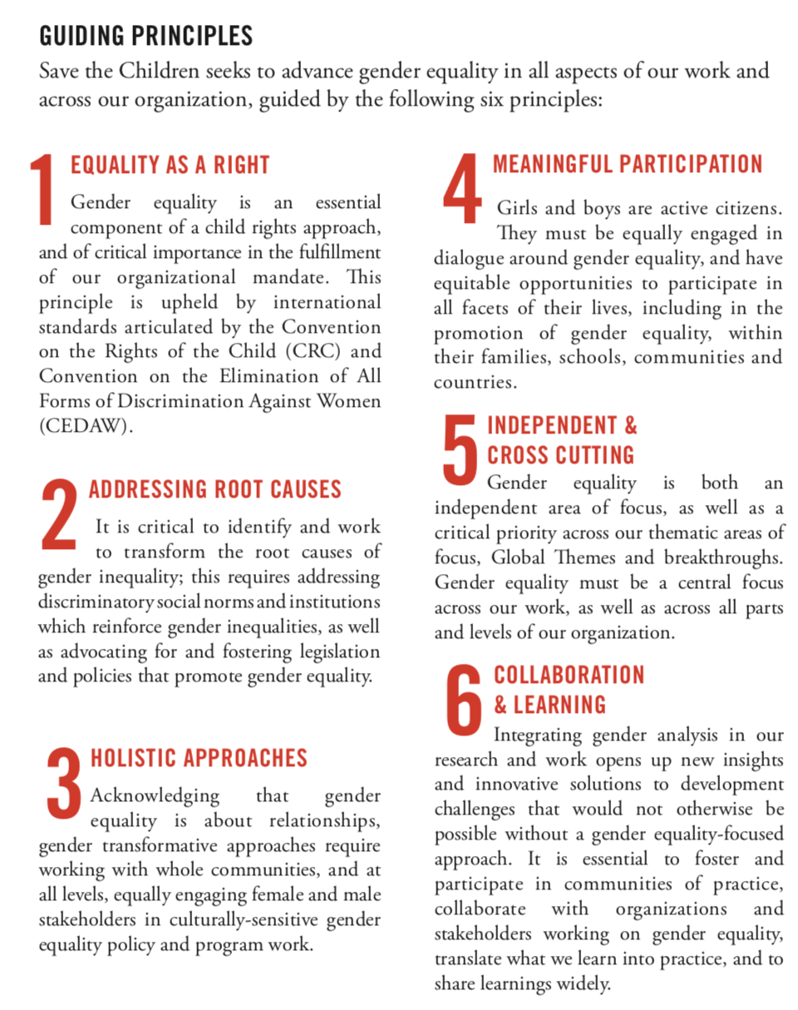
As Save the Children, it is essential that we identify and address the specific needs of girls, boys, women, and men across our program cycle if we are to fulfil our vision of a world where every girl and every boy attains their equal right to survival, protection, development, and participation. This process of gender equality integration, often called gender mainstreaming, is not only a requirement for many partners and partners, but drives positive, transformative results, and is key to effective and sustainable development.
Source: Save the Children Gender Equality Policy (2017): Transforming Inequalities, Transforming Lives (available at: https://resourcecentre.savethechildren.net/library/save-children-gender-equality-policy-transforming-inequalities-transforming-lives)

While children who migrate unaccompanied are generally at risk of not realising their rights, migrant girls are constrained in ways that require and demand differentiated and gender-specific interventions. Research shows that internationally, girls who migrate often fail to realise their inherent potential due to limited social networks, schooling disadvantage, harmful and unregulated work options, early marriage and early sexual initiation, and pregnancy. Their abuse is often less visible due to the types of violence they are most likely to experience: sexual abuse and exploitation, (also linked with) child marriage, and domestic labour exploitation, for example, are all situated within the private sphere of the household. The depth of this understanding of gender specific risks, how risks, such as mental health, affect girls differently, how these relate to migration, and how stakeholders address them to protect migrant girls, however, is lacking, particularly in the Southern African context.
The increase in female migration in Africa (from 43% in 1960 to 48% in 2000) (IOM, 2015) has generated a push by scholars and policy-makers to include gender as a category of analysis in migration studies. Studies that heed this call have in the past decade shown how gender intersects with race, class and identity to illuminate a wide range of women’s experiences in the migration process (Hiralal, 2018). In Africa, for example, there has recently been a trend of young women undertaking independent migration to pursue educational aspirations, rather than responding to the traditionally assumed motivation of visiting or joining a husband or partner abroad (Hiralal, 2018). These changing gender dynamics have implications for programmes that target girls and young women in contexts with active migration cultures.
Migrant girls often see themselves as taking action to improve their conditions, applying greater depth of agency than much of the existing (and often gender-neutral) migration literature gives them credit for. This has been confirmed in a recent study by Save the Children on migrant girls in Southern Africa. This change-making attribute makes migrant girls an increasingly important target group of potential programme beneficiaries. When girls do not fall victim to risks but instead succeed in connecting to urban resources or fulfilling migration aspirations, studies have shown that they considerably improve their chances of marrying later, having fewer, healthier and better educated children, and participating more fully in society; they are role models also for younger girls who follow in their footsteps.
4. Objective and scope of work

Save the Children seeks to commission a research study that will address targeted knowledge gaps in current literature and programme approaches in order to strengthen existing programming for girls in different stages of migration, notably during transit and arrival.

The study will investigate the migration choices, decision making processes and risks/vulnerabilities of unaccompanied migrant girls in/over the three target countries: Egypt, Ethiopia and Sudan. Specifically, the aim is look at their journeys holistically, including the decisions to migrate, their transit, and their experiences in destinations (whether temporary or permanent). Given that the project focuses on resilience and self-reliance, specific attention should be paid to girls’ current strategies and obstacles. In all the below components, the outputs should be cognizant of gender and its intersectionality with age, sex, ethnicity, disability and the likely differences in experiences of boys and girls, risks and needs of younger girls, adolescents and youth.

4.1 Research questions

In particular, the research will:

- Elucidate how gender and gender norms impact girls’ decision-making, motivations and pressures to migrate in places of origin;
- Identify the differentiated experiences of boys and girls from country of origin, during transit and at destination and establish the associated gender dynamics.
- Unpack protection risks that girls and boys face during transit, and upon arrival at destination (including intermediary destinations), and which strategies girls employ to navigate, mitigate and respond to these risks (including risks to their mental health and psycho-social wellbeing);
- Identify which sub-populations of migrant girls face the greatest risk, including looking at migrant girls who are themselves parents already;
- What is the differentiated impact of age on the experiences of girls and boys how younger and older girls differ in their experience of migration, decision making, access to services and coping strategies;
- What are the gendered effects, direct or indirect, of regional normative standards and national policy frameworks on migration?
- Assess the availability of, and barriers to accessing, gender-sensitive services (protection, education, healthcare including sexual and reproductive healthcare and mental health and psychosocial support, etc.) for migrant girls along targeted migration corridors, including the intersection with age-sensitivity and how age affects access to services for girls;

- Identify protective factors which can be strengthened through programming in order to attain gender equality in programme outcomes and better protect and support migrant girls during the different stages of the journey (for example, resilience and self-reliance).

4.2 Research Components

The consultancy will consist of three principal components:

- Literature review;
- Participatory research with migrant girls, boys and key informants (including, for example, service providers, frontline officials, and parents) in the focus countries, through focus group discussion, questionnaire and/or interviews using child-appropriate methods (following ethics and child safeguarding approval of methods and ethics protocol by Save the Children);
- Review programme document from a gender perspective and make recommendations on mainstreaming gender across the logical framework including mechanisms for reporting on gender indicators.
4.2.1 Literature Review

The comprehensive literature review will investigate existing literature to provide a comprehensive overview of:
  - available statistical data on girl migrants in the East and the Horn of Africa region;( propose to re-write- available sex disaggregated statistical data on migrants in the East and Horn of Africa region)
  - academic and NGO research on gender and migration, with a focus on girl migration and the East and Horn of Africa region;
  - literature on both displacement and irregular migration;
  - reports and evidence generated as part of the regional COM programme on the gender dynamics of child migration.

Literature to be included should look at migration in the focus countries (Egypt, Ethiopia and Sudan), East Africa, Horn of Africa, migration to Europe, and Africa at large, where regional data/research is not available.
4.2.2 Participatory research with migrant girls and key informants

For this component, field work in one or more of the following countries will be required: Egypt, Ethiopia and Sudan.

The consultant will use demonstrable experience of child participatory research techniques to involve migrant girls in a way that is ethical, safe and meaningful, in order to learn from their experiences and opinions. Any research methods and ethical protocols will have to be approved by Save the Children to ensure they meet the standards. Interviews or focus group discussions are key methods to collect information, but in each case they should include specifically child friendly and safe approaches.

The consultant will be expected to develop an outreach plan or share an approach on how girls will be reached and how their meaningful participation will be guaranteed in the research process.

4.2.3 Project Gender Analysis and Recommendations for Programming and Monitoring

The gender analysis is expected to be based on conversations with key implementing programme staff and project documentation in order to examine planned activities in light of research outcomes. The engagement with Save the Children staff should be participatory, communicating the research outcomes and recommendations, discussing the planned activities in reference to these outcomes.

The ‘gender-lens’ review of the planned activities in the selected countries should answer the following questions:

  - Are there pockets of innovation for migrant girls in existing programming?
  - Which mechanisms exist in current programming to identify migrant girls on arrival before they fall into harm’s way and disappear into border communities?
  - Which strategies exist that differentiate interventions according to gender and what we know about different needs of migrant boys and girls?
  - Which planned interventions work to reduce isolation of migrant girls in transit or upon arrival, or seek to rebuild or maintain social networks that have been disrupted by migration?
  - How do the planned interventions ‘listen’ to girls’ voices?
  - What active participation is intended for girls in the planned activities?
  - What funding sources with a thematic focus on migration are made available to a range of organisations – Non-Governmental Organisations (NGOs), country governments and private sector organisations;

Answers to these questions should result in country and context specific recommendations for programming, which, if implemented, should result in more effective protection of migrant girls and innovative programmes or interventions to address gender-specific protection risks.

This component should also include recommendations for gender-sensitive monitoring and evaluation, including guidance on developing gender-sensitive indicators that draws on the research evidence.

4. Geographic Scope and Timeline

The research will include a literature review including a regional component covering the Horn of Africa and national perspectives of the focus countries. The fieldwork is expected to take place in the three implementing countries: Egypt, Ethiopia and Sudan, with a focus on urban centres.

Timeframe
- Mid-June: commencement of work
- Early July: inception report
- June to September: data collection
- Mid-August: review of preliminary findings and progress
- Early October: first draft submission
- November: validation of revised outputs at workshop in Cairo

5. Methodology

Methodology should be qualitative and innovative. Mixed methods approaches will also be considered. It is critical that the method used is guided by a sound theoretical and methodological framework, clearly showing its suitability, especially in ensuring that girls, and their voices, remain at the centre of the research.

The active participation of children and youth, especially girls, is a minimum requirement.

6. Outputs/Deliverables

Outputs will include a report and consultative process including the following deliverables:

- Inception Report (including proposed methodology, instruments, data collection plan, overall work plan on GANTT chart);
- Research Ethics Protocol;
- Research report, including:
  - Literature Review with bibliography, including both country and regional level analysis (component 1);
  - Research Results (component 2), including country specific analysis and regional overview;
  - Practical recommendations from research outcomes to inform programming and policy, and recommendations for future studies;
- Gender Analysis of planned activities, including country specific recommendations for planned activities;
- Presentation of results at validation workshop;
- Google drive or similar containing all instruments, collected data and analysis.

7. Roles and Responsibilities

The Consultant:

- Professional and independent delivery of all above listed outputs in line with specifications given within the Terms of Reference within agreed upon timeframe.
- Quality written outputs that are of publishable quality.
- Regular and transparent reporting on progress to Save the Children, including any delays or challenges as they develop.
- Commitment to presenting results in a professional and accessible manner.
- Commitment to Save the Children’s Child Safeguarding Policy
- Ability and willingness to work with country level staff
- Submit reports in-line with communicated Save the Children and donor requirements

Save the Children:

- Supporting the Consultant in accessing programme related documents and research;
- Support with logistics for field work;
- Organize and mobilize respondents for FGDs and KIIs in consultation with the consultants
- Actively engaging the Consultant throughout the research and review process;
- Being available for feedback and review of drafts.
- Ensure all necessary permits to conduct consultations with children and adults, where relevant
- Ensure the presence of children and professionals to be interviewed and consulted during the research, where relevant

8. Competencies

This consultancy is open to both individuals and consultancy firms who meet the following criteria:
- Advanced University degree in Social Sciences, Development Studies, Law or related area;
- At least 5 years relevant professional experience working on similar assignments;
- Prior experience of researching child migration in the African context;
- Familiarity with child rights programming;
- Demonstrate experience of gender research. Research conducted in the field of gender and migration would be an advantage;
- Demonstrate experience in applied research, especially literature reviews;
- Experience of child participatory research;
- Demonstrate experience in programme reviews;
- Demonstrate experience in capacity assessment and development;
- Demonstrate strong working relationship with relevant stakeholders in respective countries;
- Demonstrate analytical and conceptual ability, good communication and facilitation skills;
- Demonstrate strong report writing skills and be able to share examples of previous work;
- Demonstrate a track record of delivering high quality written outputs on time in a consultancy environment;
- Demonstrate ability to work independently and deliver on time.

9. How to apply

Applications should consist of:

- Cover letter
- Short proposal, detailing proposed methodology, including illustrative budget (max 4 pages)
- Examples of similar work already conducted

UN DESA, International Migration Report 2017
Using UN DESA Migration Stock Data. Includes Botswana, Burundi, Democratic Republic of Congo, Djibouti, Eritrea, Ethiopia, Kenya, Lesotho, Malawi, Mozambique, Namibia, Somalia, Sudan, South Africa, South Sudan, Swaziland, Tanzania, Uganda, Zambia, Zimbabwe
IDMC
For 2017 figures, UNHCR Data portal data for November, 2017, accessed 27 Oct. 2018.
For Sudan, data on IDPs and refugees and asylum seekers from UNHCR - http://reporting.unhcr.org/node/2535#_ga=2.96842719.1354421523.1540622267-1947470501.1532431498, accessed 27 Oct. 2018.
UNHCR, Egypt Country Focus, http://reporting.unhcr.org/egypt
EU Observer. EU promotes 'Egypt model' to reduce migrant numbers. 2018. https://euobserver.com/migration/142878
Save the Children & Regional Mixed Migration Secretariat. Young and on the Move-Children and Youth in Mixed Migration Flows within and from the Horn of Africa. 2016
http://www.mixedmigration.org/wp-content/uploads/2018/06/ms-ea-1806.pdf
http://www.unhcr.org/desperatejourneys/
http://www.mixedmigration.org/wp-content/uploads/2018/09/ms-ea-1807.pdf
Yaqub, Shahin (2009), ‘Independent Child Migrants in Developing Countries: Unexplored Links in Migration and Development’, Innocenti Working Paper No. 2009-01. Florence, UNICEF Innocenti Research Centre.
Temin, M., Montgomery, M.R., Engebretsen, S. & Barker, K.M. (2013). Girls on the Move: Adolescent Girls & Migration in the Developing World. Population Council.
Save the Children (2014). Save the Children Gender Equality Program Guidance and Toolkit: Engendering transformational change. Available at: https://resourcecentre.savethechildren.net/library/save-children-gender-equality-program-guidance-and-toolkit-engendering-transformational
Ibid, 2013.

