Menu of Intermediate Indicators

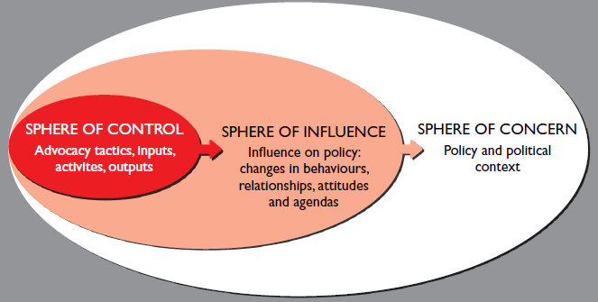
Every campaigning and advocacy strategy within our work works towards achieving one or more of the following intermediate steps to change (in the Sphere of Influence):
- Our ability to access and develop relationships with decision makers and opinion shapers to push forward our recommendations
- The evidence that decision makers, opinion shapers, partners and others are recognising our contribution in research and analysis. This may result in stronger relationships or the use of our data and recommendations in policy making.
- The ability to identify and align with partners or support partners to create platforms for civil society to engage decision makers.
- Participate in the implementation of policy decisions such as community mobilisation, awareness raising and monitoring budgets
- Public engagement which aims to work towards 3 increased levels of engagement
  - The numbers of people who are informed about an issue
  - The Numbers of people engaged in discussing, socialising and promoting the issue
  - The numbers of people who contribute or take part in an issue (such as campaigning or fundraising)
A sixth area of change is the changes in attitudes but as yet we are still struggling to understand how best to measure this work.

To support campaigners we developed a menu of indicators for each area of change, colleagues and pick and adapt as they see fit.

Area of change | Menu of Indicator
Access and dialogue: Our ability to access and develop relationships with decision makers and opinion shapers to push forward our recommendations | - The levels (no access, limited access, and increasing access) to which Save the Children have been able to push for access to key decision makers and strengthened relationships  - The first meeting between SC/partners and x Government Department (decision maker/opinion shaper) takes place  - Government holds X number of meetings with SC / coalition  - Local government officials meet with SC X times  - SC is invited to X round tables with key decision makers and/or influencers  - Government initiates a consultation with civil groups where SC is included  - SC holds X number of meetings/lobbies/presentations, etc. held with decision-makers  - X meetings between SC and X government department take place (with concrete engagement from the government, action points and follow-up work)  - Policymakers approach the SC for information and advice (x times)  - Increase in willing of Policymakers to meet and discuss key issues, demonstrated by number and content of meetings  - Personalised communication with decision-makers  Levels of interest and awareness:  - Levels of interest shown in an issue by decision makers/policy makers  - Advocacy and supportive acts undertaken by decision/policy makers  - Private and public statements of support  - Commitments made to instituting (or opposing policy)  - The issue has been raised and discussed x times in (key/significant) political forums  - Political statements of support have been made by opinion leaders and decision makers X times  - Government establishes formal mechanisms for citizens' participation on key issues  - X number of key decision makers become champions on issue and take concrete actions included in a SC action plan
Research, development and presentation of policy positions: The evidence that decision makers, opinion shapers, partners and others are recognising our contribution in research and analysis. This may result in stronger relationships or the use of our data and recommendations in policy making. | - The number of published/presented policy papers with citations and positive responses from stakeholders and the media  - SC’s publications and other evidence are cited in national & international media  - SC representatives are invited to present and discuss policy findings with key stakeholders  - SC policy recommendations are cited in round table discussions  - Decision makers recognise the contribution of SC policy recommendations formally or informally  - Evidence that policy recommendations have been adopted in decision making processes
Partnership & participation: The ability to identify and align with partners or support partners to create platforms for civil society to engage decision makers. | - SC has identified and aligned with critical partners and child-led movements through the development of networks, strengthening of existing coalitions  - SC has led or provided support to existing networks and child-led movements and these networks are functioning and have mutual accountability  - Size of networks which SC leads / is part of increases from X to Y (number of members and levels of activity)  - SC leads / is involved in the creation of X new networks  - SC provides key support to X existing networks  - Members of the coalitions SC is part of are utilising key messages in the public sphere  - Functioning strength of networks/coalitions strategic synergy, level of trust etc  - Extent to which local, national and international struggles are connected  - Extent of mutual accountability within networks/coalitions  - SC establishes X new corporate partnerships
Involvement in policy implementation: Participate in the implementation of policy decisions such as community mobilisation, awareness raising and monitoring budgets | - The number and extent to which SC has contributed to effective accountability mechanisms, and policy roll out through awareness raising and policy advice  - SC have successfully launched budget tracking initiatives with a community and there has been an output from this process  - SC have been part of a capacity building/awareness raising programme of work on increasing citizen awareness on accountability mechanisms  - SC has supported child-led accountability mechanisms
PUBLIC ENGAGEMENT
Levels of Public Awareness: The numbers of people who are informed about an issue | The number of people we reach through media and online channels, leadership of large- scale networks, sub-national outreach targets across counties.
Levels of Public Discourse: The Numbers of people engaged in discussing, socialising and promoting the issue | - X people show evidence of having discussed or socialised an initiative such as participating in a meeting, contributing views online, engaging with calls or statements, or showing evidence of distributing information relevant to the campaign within their networks.  - On social media this would include likes, comments and shares  - Profile of the issues in the media i.e. Media hits, letters published in the media, tone of the media  - The extent to which the issue is on the public/political agenda
Levels of Public Action: The numbers of people who contribute or take part in an issue (such as campaigning or fundraising) | - Size of supporter base (for countries with a database)  - Number of people mobilised to participate in a face to face event, petition signatures, participation in meetings etc (who actively took a campaign action)  - The growth of our committed activist network or other engaged supporters  - Number of people you engage each year who repeatedly participate in face to face events, petition signatures, meetings etc  - Supporters clicking through to our website and taking an action or donating

For more information contact measuringimpact@savethechildren.org

