Date: 01th August 2022
ITT Ref: ITT-AFG-KBL-2022-005
Fixed Price Framework Agreement for Various Education Kits
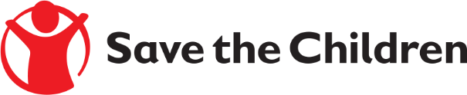
Tender Notice
Save the Children believes every child deserves a future. In Afghanistan and around the world, we give children a healthy start in life, the opportunity to learn and protection from harm. We do whatever it takes for children – every day and in times of crisis – transforming their lives and the future we share.

Save the Children International in Afghanistan is inviting submissions of tenders for Fixed Price Framework Agreement for Various Education Kits for all the Projects as following:

No. | SPECIFICATION OF SERVICES
1 | Fixed Price Framework Agreement for Various Education Kits  (Student Kits, Teacher Kits, Classroom Kits, Playing Kits, Hygiene Kits, Refresher Kit, Winter Clothing Kit and CFS Kit)

Detailed Education List including Specifications are included within the tender documents.
If you are interested in submitting a bid, please contact Afghanistan Supply chain Department at the following address AFG.Tenders@savethechildren.org to express your interest and request the tender documents. Tender documents will be sent to you by return.
It is recommended to request/collect the tender documents from the date of tender announcement to 13th August 2022 04:00 PM.

Completed tender documents are due to be submitted by 14st August 2022 before 4:00 PM Afghanistan time.

Please mention in the subject line the Tender Reference # as: ITT-AFG-KBL-2022-005 Fixed Price Framework Agreement for Various Education Kits for all the Projects and tender document will not be accepted after the closing date of Sunday 14st August 2022.

